 

Ministero dell’Università e della Ricerca

# PRIN: PROGETTI DI RICERCA DI RILEVANTE INTERESSE NAZIONALE – Bando PNRR

prot. ….

# PART A

**1– Line of intervention**

**SUD**

# 2– Research Project Title

SISTER: SocIal robotS to support biopsychosocial frailTy of sEnioRs at home for promotion of active aging

# 3 – Duration of the project (months) – 24

# 4 – Strategic emerging topic

HUMAN WELLBEING

# 5 – Related cluster

CLUSTER 1 Health

# 6– Main ERCfield

1

**7- Other ERC field**

5

**8 ‐ ERC subfields**

(Max. 3, one field is sufficient)

# 9 - Keywords

Frailty

Elderly Wellness

Social Assistive Robots

Computer Vision

AI

Education and training

**10 ‐ Principal Investigator**

Solfrizzi Vincenzo

# Declarations

x I declare that I have not participated as PI in PRIN 2022 call (n. 104 02/02/2022)

O I declare that I have participated as associated PI in PRIN 2022 call (n. 104 02/02/2022) O Current funding and applications submitted [upload pdf]

# Age limits derogation

* 1. XX

**11 ‐ List of research units** (RU)

| **ASSOCIATED PI** | **Qualification** | **Organisation** | **Registered office (address, city, province)** | **Operations office of research units (address, city, province)** | **E‐mail address** |
| --- | --- | --- | --- | --- | --- |
|  |  |  |  |  |  |
|  |  |  |  |  |  |
|  |  |  |  |  |  |
|  |  |  |  |  |  |
|  |  |  |  |  |  |

# 12 ‐ Substitute Principal Investigator (PI)* (To be identified among one of the associated PIs participating in the project).

Saggese Alessia (Associate Professor)

(Date of Birth) (Personal identification code)

University/Research institution (Phone number) (e‐mail address)

*N.B. In order to benefit from the amount allocated to under 40 PI, the substitute must be under 40 on the publication date of PRIN 2022 PNRR call.

**13 ‐ Brief description of the proposal** (Max 3.000 characters) 2997 ok!

Successful management of potentially reversible risk factors can have a beneficial impact on the quality of life and health status of elderly people and promote the so-called *active aging*. Among potentially modifiable factors, frailty represents a critical intermediate status of the aging process. Frail older people indeed are at higher risk for adverse health-related outcomes, including falls, disability, hospitalizations, mortality, and dementia.It becomes thus mandatory to support frail elderly; anyway, when elderly remain in their own house, in accordance with the “aging in place” paradigm, in many situations, one main problem is the absence of family support and the resistance by the elderly person to having an unfamiliar caregiver in the home, leading to the need of Integrated Home Care Services. In this project we explore the use of an innovative AI-based solution exploiting Social Assistive Robots (SAR) as a personal companion to assist elderly and reduce their social isolation and loneliness so as to improve their social life and led to a consequent improvement of their quality of life. SAR have been already succesfully employed in several projects as companions to assist seniors, in which the range of capabilities implemented in the robot goes from the proposal of recreational activities to physical and cognitive coaching, from friendly activity-reminders to anxiety and depression management. In most of the above mentioned projects it has been demonstrated that the social robot provided a positive experience to users (Gasteiger et al 2021). However, many of these projects used the SAR in assisted living houses and only a few experiments have been conducted in the context of seniors homes for a long period. In SISTER we aim at exploring the role of a SAR as a companion in the domestic context of seniors to unobtrusively promote, through natural communication, social engagement and empathic behavior, an active lifestyle, preventing or reducing depression states and monitoring habits and anomalies in daily behaviors. To this aim, we will study the feasibility of the presence of a SAR in the daily life of frail elderly people with critical social networks, in terms of empathy, such as willingness to undergo health promotion activities with attention to lifestyle, control of cardio and cerebrovascular risk factors and cognitive training. In addition, we will test the feasibility of this innovative device as a “collector” of data about seniors' daily-life. This will be empirically assessed by performing a pilot study on the impact of the presence of an assistive robot with two groups of users: one equipped with the robot and a control group without it. The long-term goals of this project are (i) to provide early intervention by innovative personalized digital strategies; (ii) to ensure access to transdisciplinary care and lifelong preventive strategies; (iii) to minimize caregiver burden and needs for additional healthcare services.

# 14 ‐ Total cost of the research project identified by items

| **Research Unit** | **Item A.1** | **Item A.2** | **Item B** | **Item C** | **Item D** | **Item E** | **Item F** | **Total** |
| --- | --- | --- | --- | --- | --- | --- | --- | --- |
| **Associated PI 1** |  |  |  |  |  |  |  |  |
| **Associated PI 2** |  |  |  |  |  |  |  |  |

N.B. The fields indicated in gray will be filled in automatically

**Item A.1**: enhancement of months/person of permanent and temporary employees

**Item A.2.1**: cost of contracts of non‐employees, specifically to recruit

**Item B**: cost of equipment and tools

**Item C:** cost of consulting and other services

**Item D:** overhead **Item E**: materials cost **Item F**: other costs

# PART B B.1

1. **State of the art** (Max. 5.000 characters) 4766 OK!!!

Frailty is a critical intermediate status of the aging process with increased risk for negative health-related outcomes, including dementia, hospitalization, and death (Panza et al 2019). The biopsychosocial frailty construct, combining physical and psychosocial domains (Solfrizzi et al 2019; Bunt et al 2017) was based like the deficit accumulation model on the results of a previous comprehensive geriatric assessment (Pilotto et al 2017), defining a status of biological aging and including cognitive, emotional, motivational, and social characteristics.

In the framework of a global attention strategy to the life cycles, studies underline the need for a cure expression of a relationship that is not exclusively therapeutic and the urgence for an accompaniment capable to promote well-being and existential fullness with activities related to both assistance and holistic promotion of the person. This accompaniment must draw on both rehabilitative and educational possibilities contained in multidimensional activities. A goal-oriented and empowering education, made by environmental conditions capable of activating people’s capacities, is currently suggested by literature to address both patients and family caregivers. Patients’ family caregivers are included in education (Ewing et al 2015) and by healthcare staff as informal coworkers in at-home care (McCormack et al 2006). It is assumed that family caregivers will bear some responsibility in the home context, and researchers have found that they can experience emotional, physical and cognitive burden from their new, sometimes demanding role. Psychosocial interventions have been shown to be effective at **reducing loneliness in older frail** adults (Masi et al 2011; Gardiner et al 2018; Cohen-Mansfield et al 2015). Voice-assistant mobile apps have been used to target lifestyle factors that are associated with the risk of developing dementia (Hartin et al 2016). The main limitation is the **lack of empathic interaction** with elderly, who are forced to interact with hard-to-use web-based or mobile applications.

A recent AI solution to empower assistance applications with empathic behavior, aimed to improve the engagement of the user during the interaction, is represented by humanoid Social Robots (SR) (Hegel et al 2009). A SR is described as a robot with a social interface (a robot is a programmed physical entity that perceives and acts autonomously within a physical environment that has an influence on its behavior). SR often resemble animals or humans, and several have been shown to improve loneliness in older adults (Banks et al 2008; Chen et al 2020) and prevent frailty (Keizer et al 2019). S-Assistive-R (SAR) in particular are designed and developed with the goal to provide assistance to human users through social interaction (Feil-Seifer at al 2005).

Several investigations, evaluation and feedback from participants in research studies showed that SAR is an engaging technology for elderly (Cortellessa et al 2021). SAR are being used to support older adults as companions with various functionalities and daily life services (Vogan et al 2020) such as reminding functions (e.g., taking medication or drinking) and cognitive stimulation exercises, up to detection of critical situations like falling (Antonello et al 2017). With the purpose to help people with special needs living healthier lives and connecting with others, the research challenge is designing empathic SAR able to assess and recognize the users’ affective status (Castellano et al 2021; Palestra et al 2020) and answer with behaviors simulating the empathy of human carers (De Carolis et al 2017). SAR are being used as assistive technologies for people suffering from Mild Cognitive Impairment (Law et al 2019; Pino et al 2020) or dementia (Koutentakis et al 2020). In the MoveCare project, SAR and smart objects have been integrated with the aim to monitor, assist and provide social, cognitive, and physical stimulation to seniors in their own houses (Luperto et al 2022). A long-term pilot campaign was carried out in MoveCare to evaluate the system’s acceptability and feasibility through various questionnaires and the results provide empirical evidence that SAR can be successfully used for long-term support to older adults.

This project is devoted to advance the state of the art by investigating whether SAR are an effective technology to support daily life of frail elderly living in a critical social network condition, possibly in the presence of disabilities and deflected mood. We will evaluate (i) the acceptability and impact of the presence of a SAR in seniors’ life and (ii) the presence of such an e-companion can effectively influence the quality of life and reduce their loneliness.

# Detailed description of the project: methodologies, objectives, and results that the project aims to achieve; indicate deliverables and milestones outlining the project coherence as to the strategic themes, indicating clear and innovative objectives, setting out the project sector relevance and its positioning with reference to the state of art, describing the role and contribution of each research unit (Max. 25.000 characters) 24992 OK!

# 

The SISTER project aims to define a methodological framework based on Artificial Intelligence (AI) algorithms to design and develop the cognitive architecture of a SAR intended as a companion capable of promoting social life activities and healthy habits in elderly frail people and thus improving their life quality. The project aims to answer the following research questions:

**Q1**: Which is the acceptance and usability of the SAR as a companion over long term use by frail seniors?

**Q2**: Is SAR an appropriate technology for unobtrusively collecting useful data about the senior’s behavior?

**Q3**: Are there changes that can be evaluated in the quality of life experienced by the participants?

The project will design and carry out a pilot study with pre-post-intervention evaluation and control group. One group will receive the SAR treatment that will implement contexts in which the senior can apply methods of adaptation and resilience capable of bringing out the residual potential in their own life context. Educational aspects of the project are: (i) integral promotion of the person and (ii) unity of the intervention to offer environmental conditions functional to the production of meaning and sociability.

The methodological framework will be developed to make the robot capable of tackling tasks in social contexts without human supervision, by using AI capabilities of perception, data-processing, decision making and conversation (Vasquez et al 2020). The following capabilities will be given to the SAR:

* dialogue: understand what the elderly says and properly answer in a socially accepted manner;
* entertainment: propose some activities to do together (e.g. memory training exercises, storytelling);
* monitoring: monitor the behavior of seniors to understand their habits and preferences and detect anomalies that might indicate unusual and potentially dangerous situations.

Computer Vision will be used to detect user’s gestures, emotions and actions, to derive implicitly a feedback and a degree of satisfaction of the seniors. Implicit and explicit feedback will be combined synergistically through AI algorithms for behavior understanding in order to infer preferences and habits of the elderly. To improve engagement, the SAR will be equipped with an empathy model to reason on the user’s affective state and generate suitable behaviors. To improve the elderly experience with the SAR we will pursue a non-invasive approach that uses only the robot's sensors (camera and microphone) to avoid the elderly wearing sensors. The same sensors will serve during the senior-robot interaction to gather data seamlessly and transparently. These data will allow measuring objective and standardized metrics to monitor participants' behaviour and progress over time and correlate them with other pre and post intervention measurements. A dashboard for human operators will be provided and a telepresence task will be available through the robot screen for communications with the operator and also with other involved seniors for promoting socialization.

The study will be designed as a randomized controlled discontinuation pilot trial (RCT) that targets seniors with biopsychosocial frailty (Solfrizzi et al 2019), and with vascular or lifestyle-related risk factors.

Activities and related methodologies are described below, indicating deliverables and the role of each RU. Activities are grouped in Work Packages (WPs). The outcome of each WP corresponds to a Milestone.

**WP1. Study Framing**

WP1 includes the definition of all the phases of collection, validation, preprocessing and management of project data, coming both from the screening of recruited elderly and from public databases. Indicators will be discussed, defined and approved in this phase. WP1 implements and guides a user-centered design cycle to give guidelines in other WPs.

Activities:

**A1.1 Study Indicators and Evaluation metrics (RU1 RU2)**

The activity will begin with the analysis, definition and validation of proposed indicators and evaluation metrics, together with models for their calculation. Some data necessary for their calculation will be acquired through dialogs with the robot sensors, CV techniques, and NLP. Evaluations of the behavioral indices obtained through sensoristics will be jointly evaluated and monitored by psychological, medical, and computer science experts.

Deliverable D1.1 Study Indicator and Evaluation Metrics BIM1-I

**A1.2 Study Protocol Definition (RU1 RU2)**

This activity will define a suitable protocol for data acquisition and development of a benchmark database on consequences and effects of loneliness in frail elderly people. The anonymization procedures will be defined. Each elderly participant will have an identification code so data will be pseudonymized to allow subsequent integration. Anonymous data will be stored on a secure server. Access to the server from outside will be possible only through SSH tunneling for authorized users with a private access key. Access to the dashboard will be only for users with authentication privileges. Also, the logs of the users having access to specific data will be stored. Attention will be paid to compliance with the highest ethical, fundamental rights and legal standards relating to data privacy rights (GDPR) as recognized by the European Union. The request for study approvals will be obtained from the Ethic Committee of UNIBA; written informed consent will be signed by both elderly participants and controls. Participants will be recruited in collaboration with the SIRIO COOPERATIVA SOCIALE located in Bari (Italy) that provides non-residential social assistance for elderly and disabled people, including social health services, educational services, professional nursing care, house assistance, assistance to nurseries, household and listening space, and communication and social secretariat. Founded in 2007, this Cooperativa has been involved in several scientific projects to investigate prevalence and incidence rates of common chronic conditions in the older population, and the identification of their risk and protective factors. For each participant, we will collect all the available data (clinical evaluation, cognitive test results) stored by the Cooperativa.All participants will undergo pre-intervention, post-intervention test administration. Participants will be assigned to an experimental group and a control group according to the procedure specified in WP4. A validation and standardization phase will be initiated for the scales constructed specifically for the project.

Deliverable D1.2 Definition of the Study Protocol BIM1-I

**A1.3 User-Centered Design (All)**

This activity involves the end-user in the design process with the goal to optimize the usability and the user experience (UX) of a product. The cycle of design-evaluation, implementation-evaluation using an iterative approach, will be defined and validated. Based on the outcome of this activity, conversational interfaces for interaction with the robot will be implemented. The same approach will be used for the human operators dashboard.

Deliverable D1.3a-b User-Centered Design BIM3-I, BIM6-I, BIM2-II

**W2. Design and development of the AI modules**

WP2 aims to develop the SISTER system by applying AI methods and assessing their potential in the development of intelligent tasks needed to equip the SAR with capabilities of a friendly companion. Computational methods and deep learning architectures will be investigated to learn specialized models from different sources of data (video, images, voice) related to the daily life of frail elderly people. Standard databases will be used as initial benchmarks to develop the models that will be later tested on the real cases of the invivo experimental setting.

Activities:

**A2.1 System design: architecture and tools (ALL**)

We will define both the hardware and the software architecture. The hardware requirements of the robot will be defined. From a software point of view, we will define the software architecture, the real-time requirements, the communication between the software modules, the tools and the standards to use. The software architecture of the robot will be based on the Robotic Operating System (ROS), the standard middleware used in robotic applications, so as to guarantee modularity, inter-platform and inter languages operability and concurrent resource handling. The skeleton of the architecture will be also implemented at this stage. The software modules and the SISTER architecture are shown in Fig. 1.

Deliverable D2.2 Design architecture and tools BIM3-I

Figure 1. SISTER architecture

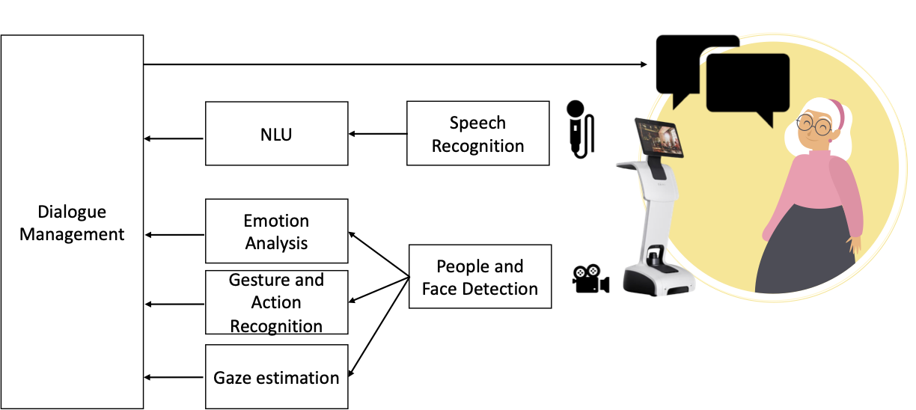

**A2.2 Conversational AI (RU2)**

The conversational skills of the robot require two main AI capabilities: Automatic Speech Recognition (ASR), for translating or transcribing an audio signal into a written text, and Natural Language Understanding (NLU), for obtaining a semantic interpretation from the (previously) transcribed text, i.e. understand the interlocutor’s intents and the involved entities. NLU together with a Dialogue Management module in charge of generating proper answers, equips the SAR with the following skills: (i) chat about some generic topics with the human and propose to start some joint activities, trying to maximize user engagement; (ii) Task-Oriented Dialogues for promoting conversations with a specific goal (i.e. medicine reminder, food information, cognitive stimulation games, etc.). For both tasks, the robot will also maintain information about the human preferences, thus avoiding proposing an activity the person is not interested in it. In this way the interaction experience of the elderly improves day by day, thanks to the knowledge stored in his profile. It is important to highlight that a misunderstanding (i.e. an error in the above mentioned modules) can result in a bad user experience due to incorrect answers or unwanted actions of the SAR, and could thus decrease the enthusiasm of the elderly in interacting with the robot. The main challenge is that humans can express the same intention in several ways using natural language; for this reason, pattern matching approaches are impractical (Louvan et al 2020). Inspired by the literature, we will exploit a Connectionist Temporal Classification (CTC) model based on Conformer encoder for ASR, since it has been proved to be the best trade-off between the recognition rate and the inference time (Lee et al 2021). For the NLU we will adopt the Albert architecture (Lan et al 2019) which has been proved to obtain comparable performance w.r.t. the popular BERT one, while gaining a speed-up of more than 3x. To reduce the computational complexity of the neural network to deploy on board of the robot, Albert will be fine-tuned as a joint NLU model in which the output embeddings are used for both intent and entity recognition. This approach gives a double advantage: the number of parameters is halved with respect to using distinct models for the two tasks; moreover, optimizing the shared parameters, the two tasks can share useful context information and improve the performance.

Deliverable D2.2 State of the art and method description BIM5-I

Software S2.1 Prototype of the Conversational AI module BIM5-I

**A2.3 Multimodal Emotion Recognition ~~Module~~ (RU1)**

The real-time analysis of the senior’s emotional state is a challenging task since aging has an effect on face and voice. We will develop a multimodal emotion recognition approach that combines Facial Emotion Recognition (FER), Speech Emotion Recognition (SER) and Text Emotion Recognition (TER). To this aim, methods for FER, SER and TER previously developed by RU1 will be fine-tuned on specific datasets concerning faces and voice of seniors by applying transfer learning approaches. A FER model based on Action Units (Castellano et al. 2022) which achieved good results in recognizing emotions from facial expressions in elderly, will be refined to account for the dynamics of facial expressions in the wild and overcome problems due to wrinkles. A SER model based on recurrent deep neural networks will be refined on the seniors' voices for a better emotion recognition during conversations in the wild. A TER model for sentiment polarity classification based on a bidirectional architecture of transformers will be refined on emotional texts.

Deliverable D2.3 State of the art and method description BIM5-I

Software S2.2 Prototype of the Multimodal Emotion Recognition module BIM5-I

**A2.4 Engagement detection (RU1)**

Gaze and eye contact enables the evaluation of social communication skills and the analysis of engagement during social interactions. Software already developed by RU1 in the context of human-robot interaction will be used to detect eye contact and measure engagement duration. The model will be fine-tuned to learn the peculiar condition of eye contact in the interaction with older adults.

Deliverable D2.4 State of the art and method description BIM5-I

Software S2.3 Prototype of the Engagement detection module BIM5-I

**A2.5 Activity and Gesture Recognition (RU1)**

Promising techniques for non-invasive recognition of human gestures and actions are based on computer vision models. Existing deep learning models previously developed by RU1 are based on graph convolutional networks trained on the dataset NTU RGB+D 120 (rose1.ntu.edu.sg/dataset/actionRecognition/) which contains several actions typical of the daily life. We will extend the existing models by enriching the dataset with actions and gestures typical of the project domain.

Deliverable D2.5 State of the art and method description BIM5-I

Software S2.4 Prototype of the Activity and gesture recognition module BIM5-I

**A2.6 Modeling Empathic Behavior (RU1)**

Multimodal emotion recognition will allow the robot to reason and act empathically according to a computational model of empathy that will trigger the most appropriate behaviors. The reasoning will be modeled by consolidated formalisms, such as Dynamic Belief Networks and Fuzzy Logic, that are suitable to simulate human reasoning by dealing with uncertainty, typical of natural situations that evolve during time (De Carolis et al 2017).

Deliverable D2.6 State of the art and model description BIM5-I

Software S2.5 Prototype of computational model of empathy BIM5-I

**A2.7 Dashboard for the human operator (All)**

The operators working in the project will use a dashboard during the study (on smartphone, tablet or PC) for monitoring and checking results and setting specific interventions. The dashboard will also provide a telepresence task.

Deliverable D2.7 Requirements and Design of the Dashboard BIM5

Software S2.6 Prototype of the dashboard BIM5

**A2.8 Educational models and empowerment-based training tools (RU1)**

Being elderly education the core of advanced care, the project will design educational practices for engaging elderly in active participation and self-care. Moving from an education as the delivery of general *information* responding to assumed needs, we will design a user-centered approach, incorporating a focus on what elderly themselves can do for their health and well-being in their everyday context. Such advanced education does not solely include a focus on information but also coaching, guidance and support (Tracey et al 2018). Serious games and storytelling are useful approaches to achieve this goal (Hydén 2013). We will provide educational contents for a standardized seniors engagement curriculum and develop a specialized educational model on elder-robot interaction, made by report on elderly needs’ analysis based on literature and interviews with volunteers, professional carers, informal carers/relatives, management and policy makers and old adults).

Deliverable D2.8 Educational models and empowerment-based training tools BIM5-I

**WP3. Integration, test and demo**

The AI-models developed in WP2 will be integrated into a unified framework for supporting the different tasks of the robotic companion, thus enabling the development of a demo prototype to be used for validation and refinement. The methodologies will be individually and comparatively tested with each other and with those of the literature, to establish the advancement of the state of the art they provide.

Activities:

**A3.1 Integration and demo prototype development (All)**

An integrated model handling multiple data at once is more desirable than an ensemble of models, each dedicated to a single task. The efficiency regards not only memory and speed but also data exploitation, as related tasks can share informative features. Flexible deep learning frameworks will be leveraged to define a multi-input model that integrates multiple network branches corresponding to AI models developed in WP2. The design of the integrated architecture is a key-point: it should orient the network to learn generalizable shared representation while providing the ability to keep task-specific features. Besides integration, this task is also intended to test the system both at unit level and at the general level. Each RU will test modules of the system, then a Demo system will be deployed to evaluate the solution as a whole.

Deliverable D3.1 Demo prototype system BIM6-I

Software S3.1 Demo prototype system BIM6-I

**A3.2 System calibration and model refinement (All)**

In system calibration, a crucial role is played by clinicians who are called upon to visualize and evaluate the results of the SISTER methodology. This task aims to define how the feedback from the clinicians involved in the project team should be provided to and incorporated in the system for final tuning. We will follow a design-evaluation-implementation-evaluation cycle using an interactive approach (UCD design), with a repeated cycle of refinement and testing. We intend to involve all stakeholders and have them contribute in the various stages of a collaborative and participatory process, to co-refine the final prototype with them.

Deliverable D3.2. Overall system BIM1-II

Software S3.2 Overall system BIM1-II

Milestone M1 Overall SISTER system BIM1-II

**WP4. Pilot Trial and Evaluation (All)**

The SISTER pilot trial is expected to include up to 40 participants (20 per arm). The recent CONSORT extension guidelines for developing and reporting pilot RCTs state that “no hypothesis testing is recommended” for pilot trials (Thabane et al 2016). No formal sample size calculations are needed because the primary outcome measures are feasibility (recruitment and intervention acceptability – i.e., adherence and retention), safety and adherence to the multimodal intervention in biopsychosocial frail elderly individuals. All analyses will be conducted at the group level. The two trial arms will be compared to assess the differences in the primary, secondary and exploratory outcomes. Fig. 2 overviews the study design.

Figure 2: Study Design (1): Inclusion and exclusion criteria and description of the first phase and the baseline of second phase

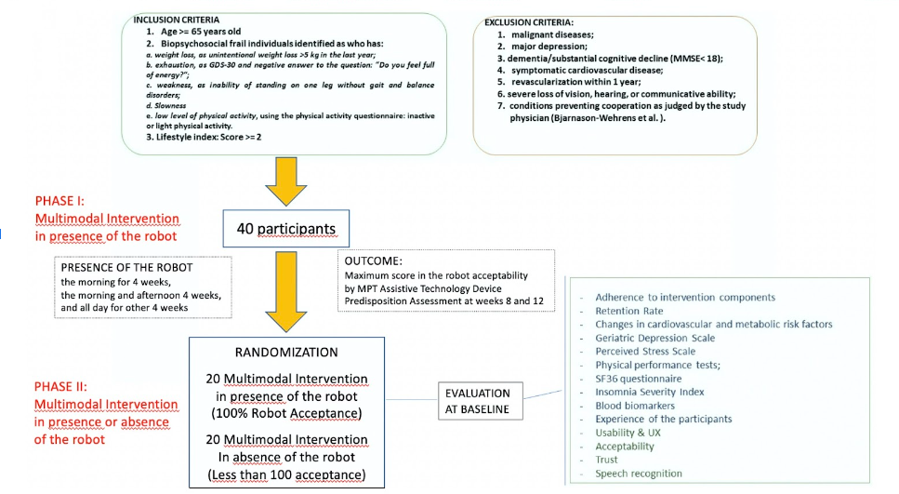

Seniors (40 in total), selected according to inclusion and exclusion criteria, will receive open-label multimodal lifestyle intervention (nutritional guidance, exercise, cognitive training, vascular/metabolic risk management and social stimulation) proposed by the robot for 12 weeks. The presence of the robot and its involvement in the intervention will be introduced gradually, i.e. the morning for 4 weeks, the morning and afternoon 4 weeks, and all day for other 4 weeks. The stepwise introduction of intervention components will promote adherence as shown in Fig.3.

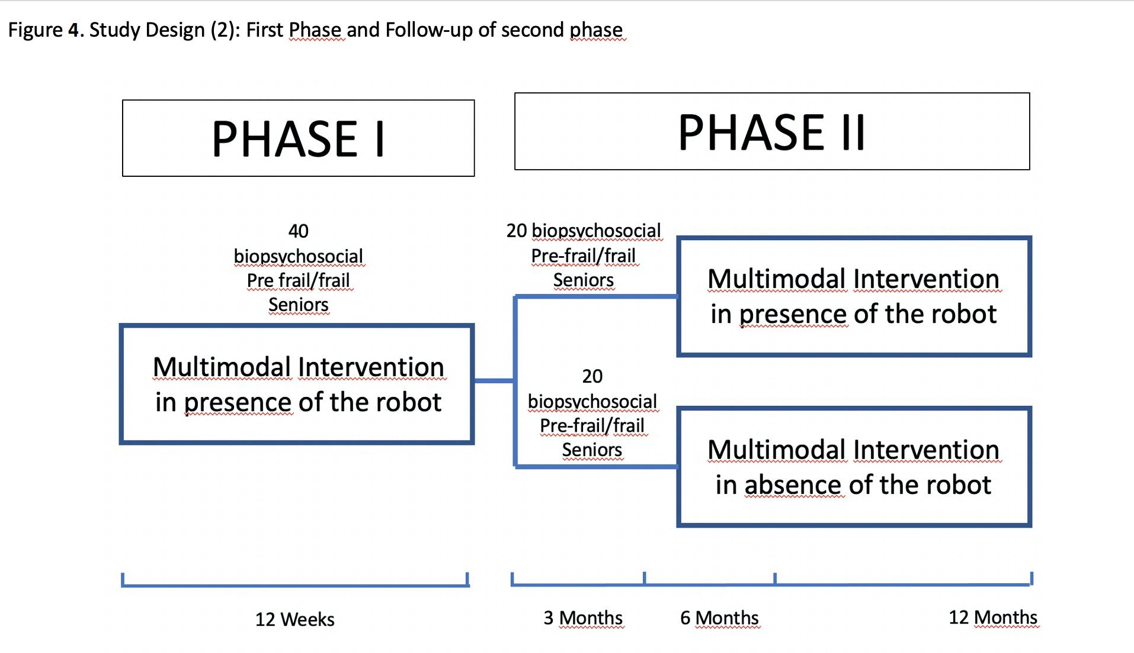

All intervention components will be standardized, ensuring similar intervention content and intensity for all frail elderly participants at home. A Lifestyle Index (LI) will be used for screening to identify biopsychosocial frail individuals with multiple modifiable vascular or lifestyle related risk factors and thus potential for improvement. Table 1 shows a sample table to compute the LI in SISTER.

**Table 1 – LI Score**

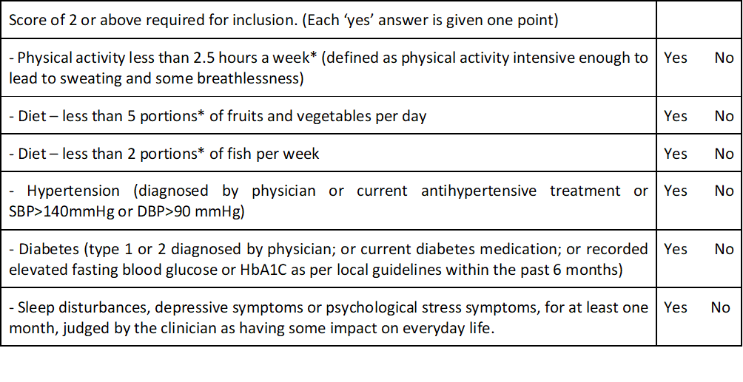

Assessment at weeks 8 and 12 will be randomly assigned in a 1:1 ratio to continue receiving multimodal lifestyle intervention with the robot in one arm or without the robot educational advice in the other arm for up to 52 weeks. We will consider 6 months for the recruitment. All participants (control and intervention group) will meet the study nurse at screening, baseline, at 6 months, and at 12 months for measurements of blood pressure, weight and BMI, and hip and waist circumference. All participants will meet the study physician at screening and at 6 months for a detailed medical history and physical examination. At baseline (6 months), the cognitive status will be assessed by a psychologist, and information on health status, lifestyle, demographic and socioeconomic factors will be collected (Fig. 4).

Figure 4: Study Design(3): Details of multimodal intervention

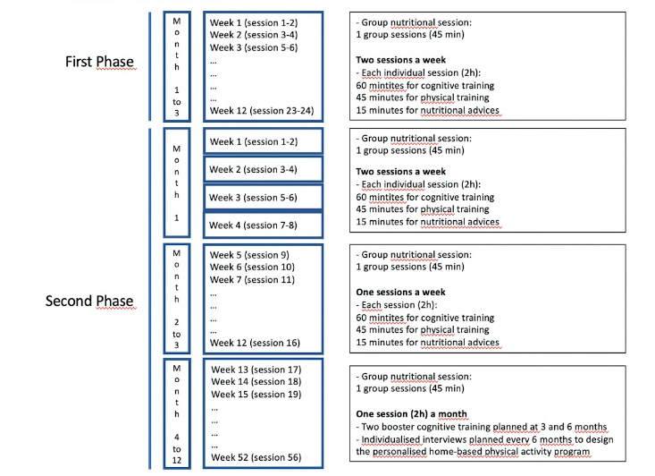

In the robot intervention arm, the usability and UX, trust and acceptability will be evaluated following the User-Centerd Design (UCD) approach according to criteria in Table 2.

**Table 2. Aspects that will be evaluated in the intervention group with the robot**

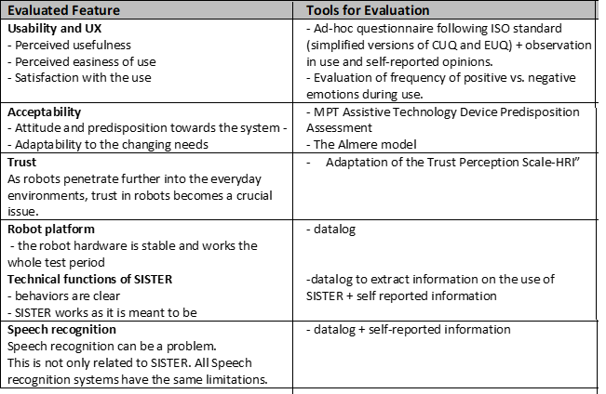

The primary outcome of the pilot trial is feasibility of the multimodal intervention expressed in terms of retention rate and overall adherence to the intervention measured in the intervention arm. Expected secondary and exploratory outcomes are described in Fig 5.

Deliverable D4.1 Report on primary outcomes BIM5-II; D4.2 Report on secondary outcomes BIM5-II

**Figure 5**

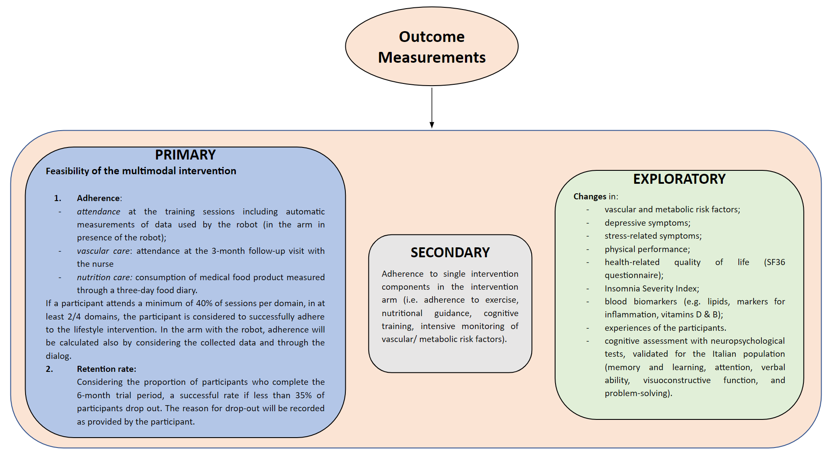

**WP5. Communication and dissemination**

The promotion of the project outcomes will aim at raising awareness of the advantages of using the technologies developed to reduce loneliness and improve life of frail elderly people. The communication will emphasize the ability of SISTER to integrate innovative AI solutions implemented in SAR with human expertise. A further goal is to network all the local entities of the territory: universities, research lab and centers, companies and start-ups. This is likely to result in a greater awareness of these ever-increasing health problems not only among experts but also among the population. The Leader RU, in particular, will be engaged in the effective transfer of research results and in the development of collaborative forms to strengthen an effective internal and external partnership.

Activities:

**A5.1 Communication (All)**

A web space containing information and project-related contents will be realized also to systematize the results achieved. Social media channels will be maintained to better disseminate the project milestones.

Deliverable D5.1 Website and communication channels activation BIM1-I, BIM6-II

**A5.2 Dissemination (All)**

The project intends to achieve objectives and outcomes through a threefold dissemination strategy that envisages the involvement and participation of a high number of stakeholders (Fig. 6).

Figure 6: Athreefold dissemination strategy

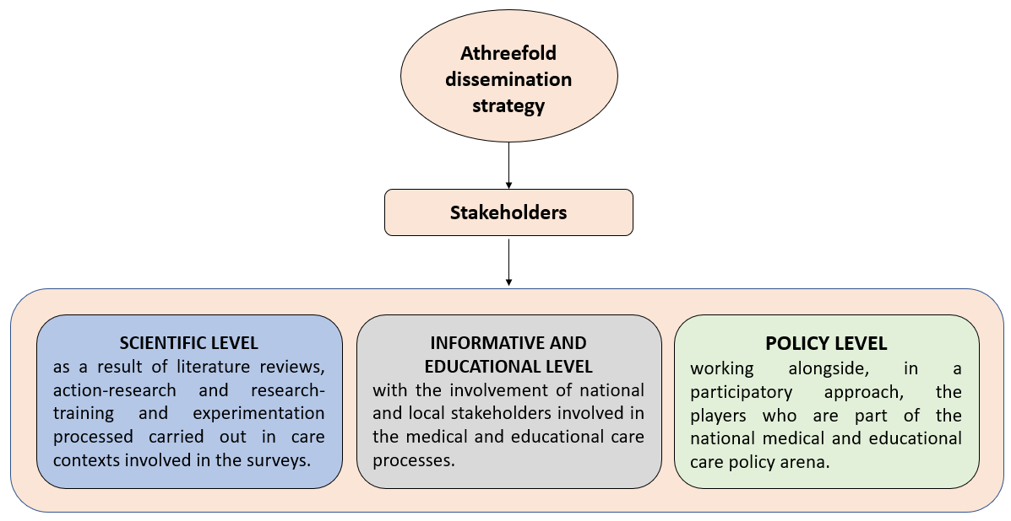

Seminars will be organized in universities and companies belonging to the RUs to effectively disseminate the results of the project. Special sessions and workshops will be organized within international conferences in the field, to illustrate to the scientific community solutions and preliminary results, exploratory or not. The consolidated results will be proposed for publication in open-access peer-reviewed scientific international journals in the field. Being a pilot study, results can be of interest not only to clinicians and therapists but also to companies working in the field of assistive technologies. A final event will be organized to make them informed about the results of this study and exchange ideas on the use of innovative technologies as commercial assistive applications. A further channel for disseminating the results will be the website dedicated to the project updates and progress, wherein we will make the deliverables available and we will publish all the initiatives and publications of the obtained results.

Deliverable D5.2 Paper collection BIM2-I, BIM6-II

**WP6. Project coordination and management (RU1)**

This WP includes technical, financial and administrative coordination activities of the project. The coordinating RU will work in close collaboration with the other RU to define the key aspects of the project and discuss strengths and weaknesses. The main objective of the WP is to guarantee a smooth and seamless connection and communication between the partners, as well as with the MUR. Project coordination and management will be handled by the PI who will be responsible for the overall project strategy including project planning, quality assurance and risk management. To this end, best practices and well known standards will be followed. From a scientific point of view, the PI will review the deliverables to verify consistency with the project tasks and prepare the final reports. The RUs and the received financial

contribution will be managed by the Associated Investigators. To ensure the quality of the project, a Quality Assurance Plan will be defined. It will include the procedure for quality monitoring and assessment of all project tasks. As specific purposes, the Quality Assurance includes two main purposes (Fig 7).

Deliverables D6.1 Internal reports at BIM2-I, BIM4-I, BIM6-I, BIM2-II, BIM4-II; D6.2 Final report BIM6-II

Figure 7: Quality Assurance

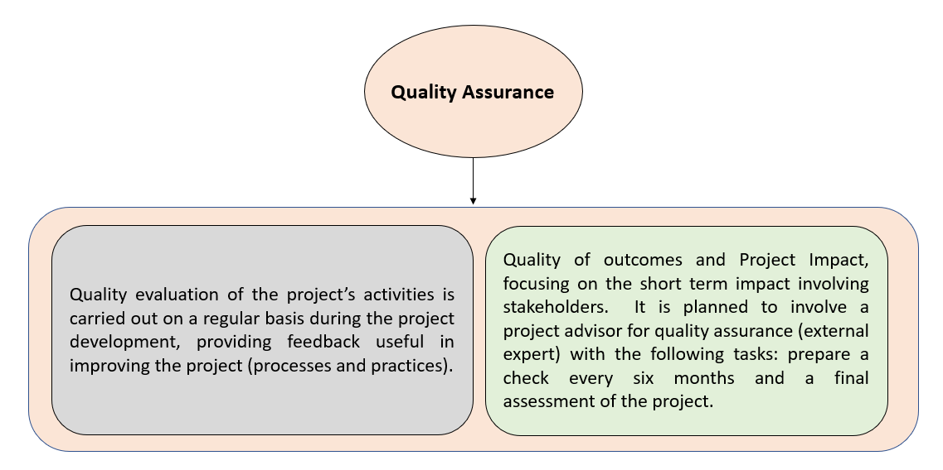

Figure 7

1. **Detailed description of the project team and planning; indicating the research team components – PI and associated PIs ‐ and their relative expertise/track record, gender equality of the composition, the interrelation and coherence of the team components. RUs‐ and the feasibility of the project, thus outlining the congruity between objectives, timing and costs** (Max. 15.000 characters) 6027

The project team was chosen thoughtfully to ensure the proper achievement of the project objectives and activities, considering human resources with diverse skills in multidisciplinary fields. The following RUs will work on the project:

RU-1. UNIBA:

This RU includes researchers from the following departments of the University of Bari Aldo Moro (UNIBA): Interdisciplinary Department of Medicine, Department of Informatics (DIB) and Department of Scienze della Formazione, Psicologia, Comunicazione (ForPsiCom). A consolidated synergy already exists between these department that are currently involved with the CITEL (Centro Interdipartimentale di Telemedicina, UNIBA) in the AMICA. project Traiettoria 1 - “Active & Healthy Ageing - Tecnologie per l’invecchiamento attivo e l’assistenza domiciliare” Azione 1.1 "Creazione di uno spazio urbano dedicato alla vita delle persone anziane" del Piano Sviluppo e Coesione Salute - FSC 2014-2020, approved by the Italian Ministry of Health (Traiettoria 1 - Gestione a distanza degli anziani - https://www.salute.gov.it/imgs/C_17_bandi_252_13_file.pdf).

The Interdisciplinary Department of Medicine embraces, in the same structure, more than one hundred researchers, professors and other professionals belonging transversally to numerous scientific fields of biomedical research ensuring a research environment characterized by high interdisciplinarity. In fact, the Interdisciplinary Department of Medicine operates in numerous clinical and research fields: clinical microbiology, internal medicine, endocrinology, odonto-stomatological diseases, maxillofacial surgery, diagnostic imaging and radiotherapy, pediatric medicine, geriatric medicine, gynecology and obstetrics, legal medicine, food science, and technology. The PI of the SISTER project pertains to this Department.

The DIB participates in the CINI National Laboratory on Artificial Intelligence and Intelligent Systems (AIIS), in the CINI National Laboratory on Big Data and the CINI Laboratory of Digital Health. The DIB has numerous projects on related topics, e.g. the TALISMAN project (Tecnologie di Assistenza personALizzata per il Miglioramento della quAlità della vitA’, PON R&I 2017-2020). DIB has a multi-decade record track of activities in the areas of Machine Learning, Computational Intelligence, Computer Vision, Intelligent data analysis, Affective Computing and Social Robotics with a specific focus on applications in health and well-being. DIB researchers have already developed AI and algorithms suitable to provide targeted suggestions based on the preferences of the users and the context in which they live; recognize and monitor the elderly user's state of mind through the analysis of facial expressions, gestures and postures. DIB participants in the project are Giovanna Castellano (Associate Professor) and Berardina De Carolis (Associate Professor).

The Department of Education, Psychology and Communication Sciences at University of Bari Aldo Moro (“ForPsiCom”) includes researchers with experience in the research areas of e-Health, educational, training and communication processes, education technologies and new media (design and management of LMS platforms, implementation of apps, serious games and gamification actions), inclusive and continuous education. In particular, the interdisciplinary group "DidaSco" - coordinated by Loredana Perla – involves a team that is particularly active in experimenting with advanced media communication methodologies, in the processes of evaluation and certification of professional skills, in the development of data collection and analysis tools (development of tests and questionnaires, survey), in the actions of prevention, promotion and dissemination of best practices in the educational and welfare institutions of the territory: the Department in fact has countless conventions, agreements and network projects that will guarantee the widest dissemination of the actions and results of the project. For.Psi.Com participants in the project are: Loredana Perla, Professor of Didactics and Special Pedagogy, Director of the Dpt. ForPsiCom and Head of Citel - Telemedicine Center at the Giuri Education in Brussels, research unit "E-health education and wellbeing"; Antonella Montone, associate professor in Mathematics Education, and Stefania Massaro, researcher in Didactics and co-cordinator of Citel Telemedicine Research Centre research unit ‘E-health education and wellbeing’

RU2-UNISA:

This RU includes researchers from the MIVIA laboratory (Intelligent Machine for Video, Image and Audio recognition) of the Department of Information and Electrical engineering and applied Mathematics (DIEM) of University of Salerno. All the MIVIA’s researchers belong to the International Association of Pattern Recognition (IAPR) and to the CINI National Laboratory on Artificial Intelligence and Intelligent Systems (AIIS). They are active from more than 30 years in the area of machine learning and pattern recognition for text, video, image and audio analysis applied in different big data contexts. MIVIA participants in the project are Alessia Saggese (Associate Professor) and Lidia Fotia (Tenure Track Assistant Professor). Among the projects MIVIA lab is currently involved in, we can mention the European H2020 FELICE project, where the aim is to design industrial robots working as a personalized assistant for the human operator on the production line, thanks to a command-based interaction based on both speech and visual commands; PRIN I-MALL project, whose goal is to personalize the advertisement contents, by means of a social robot able to autonomously interacting with the human.

RU1 and RU2 share a common and complementary background in AI, Computer Vision, Affective Computing and Robotics with expertise in AI applications in healthcare.

RU1, besides the expertise in computer science, offers medical and educational one that allows to face up the goal of the SISTER project from a multidisciplinary point of view. The medical expertise of the PI in the field of aging society will allow to properly define and guide the study that, supported by the experience of researcher of the DIB and For.Psi.Com, will allow to measures the outcome of the proposed methodology on a sample of older frial adults.

RU2 has long standing expertise in research about AI systems to be equipped on board of cognitive robotics platforms, aiming at working in the wild, in real-time and optimized for processing on board of smart cameras or low-power embedded devices (such as the ones our social robot will be equipped with). These complementary skills form the basis for a fruitful collaboration within the project.

The members of the project team share significant past and current experiences in the planning, scientific and organizational areas related to the use of social robots and advanced sensors for well-being and health of the elderly as the project 'AMICA. Intelligent Holistic Care for the Active Aging in indoor and outdoor ecosystems' Public notice Italian Health Operational Plan (FSC 2014-2020), Trajectory 1 “Active Ageing; Healthy Aging - Technologies for active aging and home care", Line of action 1.1 "Creation of an urban space dedicated to the life of elderly people" aimed at researching and and developing innovative AI-based solution for the accompaniment of the person in different phases of the aging process in different residential contexts.

RUs and the feasibility of the project, thus outlining the congruity between objectives, timing and costs

As project coordinator, RU1 will be responsible for project management. It will supervise all the activities, including the integration of all contributions. Each RU will be engaged in non-overlapping but tightly coupled research tasks. Technologies for collaborative work will be used to enable a fast information exchange even when working from distance. Meetings are also planned, in the beginning, at the middle, and at the end of each work package. Each RU is specialized in the task to be performed; some infrastructures (social robots) and tools are already available at no additional cost. Each Associated Investigator, including the PI, has a strong experience and a considerable track of publications at international level related to the research activities of the project.

The project aims to involve and train young researchers (aged <35, possibly holding a PhD). Seminars and case studies will be carried out to promote master’s or doctoral degree theses to bring brilliant students closer to the project research topics. If possible, some specialized research contracts will be considered, also taking into account international scientists. To find a compromise between work overload and activity management, the project work plan is organized into 6 work packages (WPs). The first four WPs address diverse aspects of scientific research, transversally overlying the different activities of the RUs. The fifth WP is devoted to the dissemination of results. The last WP is related to project coordination and management.

The time schedule of the research activities is illustrated in Section 7.

fig 2=0010

fig 3=0016

fig 4 = 0018

fig 5 = 0015

fig 6=0012

fig 7 = 0013

# Detailed description of the Project impact, as such; indicating knowledge improvements, technological innovation and/or industrial applications, scientific community reinforcement, level of research internationalization, dissemination and exploitation of the results (Max. 15.000 characters)10635

Scientific community reinforcement and knowledge improvements

The outcomes of this project will contribute to reinforcing the scientific community by providing innovative solutions to different scientific challenges. The proposal of a robotic assistant capable of collecting data of different nature about frail elderly, including behavioral data, vocal data, images, etc., is innovative since only recently has the topic begun to be investigated in the literature. An original contribution will be the (i) creation of a new and more complete multimodal database of aggregated and anonymized data will be made available on request for the research community, and would therefore be an important achievement as it could become a new reference database, integrating behavioral data and frailty-related data of the study participants, to promote further advances in national and international research on the relationship between frailty and neurodegenerative diseases.

Also, this project (ii) could help to provide a new understanding of the relationships between frailty, loneliness and quality of life and identify new patterns of interest. The “information poverty setting” due to the different nutritional habits of seniors (depending on age, geographical residence, health status, etc ) will make the dataset sparse from the point of view of the number of similar subjects, but it could be dense from the point of view of the feature dimensionality.

(iii) Extracting useful knowledge from such sparse data represents another methodological challenge and therefore a further scientific contribution. (iv) Also, the AI algorithms that will be designed and developed within this project have to be optimized in order to run still in real-time and in the wild but over embedded and low-power devices, with limited resources capabilities.

The results of the empirical validation that will be carried out through the experimentation of the methodologies developed in this project will be generalized in order to be used by researchers, even those not included in this project, for the further development of innovative knowledge.

Technological innovation

The technological innovations introduced by the project have the effect of making digital technologies accessible and sustainable to a large number of users, activating virtuous processes of aggregation. The areas of intervention mainly identified are those that are best suited to constitute exemplary cases with characteristics of demonstration and transferability and with a clear impact on the economic and social environment of the national territory. The project will provide targeted and sustainable technology transfer processes that will benefit end-users of innovative technologies capable of greatly improving the automation of the health data analysis process, so as to reduce the intensity of manual labor and minimize subjective randomness. Technology can also contribute both directly and indirectly to caregiving, reducing demands on families and formal services, which are major contributors to the economic costs of elderly assistance. As data records grow, the systematic knowledge produced by the project will be enriched, and knowledge will be accumulated and analyzed automatically or semi-automatically to improve treatments and provide decision-making support for disease prevention and monitoring in the future. The adoption of computational and intelligent techniques is in line with the expectations, provided by numerous authoritative associations and surveys, that new professional figures, such as the AI-assisted healthcare technician, will emerge in the near future.

Social and economic impact

The results that the project aims to pursue are transformative and their impact is envisaged at multiple levels (macro, meso and micro).

1) At micro level: seniors are empowered by activation and engagement in an integrated multimodal intervention as evidenced by attitude, knowledge and needs measurements and usability and acceptance analysis that will be developed.

2) At meso level (caregivers and healthcare services): involvement and empowerment of operators in the management/interaction processes of/with new technologies: operators involved in the project (care givers and social-health operators ) will be trained and up-skilled in order to be able to interact appropriately with the robots, considered as "facilitators" for their activities as a decision support and decision making tool, but not a substitute for their work; local healthcare services will have the possibility of carrying out AI-based assistance paths and community-based educational approaches for interdisciplinary preventive actions

3) At macro level the project will:

- support citizens in pursuing healthy and active lifestyles and behaviors, making healthier choices (such as healthier food choices) and maintaining longer a healthy, independent and active life with a reduced disease burden, including at older ages

- strengthen citizens ́ trust in knowledge-based health interventions and adherence to effective strategies for health promotion, diseases prevention and treatment,

- develop knowledge-based health policies and actions for health promotion and dementia prevention targeted to citizens' needs

- contribute to a more inclusive and social health system providing access to preventive and high quality health care with accessible innovative solutions for active ageing.

The project will implement the Patient-Centered Care model in healthcare considering the behavior of the elderly not only as the result of physiological and biochemical modifications but as an active response to enriching environments and promoting community-based empowerment for active and independent aging. The results obtained can be transferred to residences for the elderly which today increasingly have to move from healthcare institutions to welcoming communities capable of promoting adaptation and resilience with educational and recreational activities, and can be shared with services that currently have to reorganize themselves according to a multidisciplinary work on the elderly, with an emphasis on productive life and reduction of drugs.

Transdisciplinary research approach

The strong role of educational research for dementia prevention currently relates to the need to promote transdisciplinary research orienting current societal changes towards a person-centred direction. These processes require cultural hybridizations capable of addressing global problems, as cognitive decline prevention and health promotion. To this aim, SISTER’s educational research will develop the social participation of the patient to be democratically involved in digitalized healthcare systems and engaged in healthier lifestyles. Connecting medicine and education, SISTER will respond to the urgency of complex knowledge with a focus on solving problems for what is perceived as the common good, working on the interface between science, society and politics. Towards equity-based healthcare systems the Humanities claim the social element of medicine, orienting the perspective on socio-cultural issues that affect health and well-being such as inequality and discrimination. They correlate the disease prevention with contextual processes underway, highlighting the need for a culture that must be both scientific and of human and social respect. Elderly empowerment will be developed.

​​Gender dimension

Lifestyle factors such as smoking, excessive alcohol use, and poor diet modulate susceptibility to dementia in both males and females and the degree to which the resulting health conditions (eg, obesity, type 2 diabetes, and cardiovascular disease) impact dementia risk varies by sex: according to some studies females are at greater risk of developing Alzheimer disease dementia, whereas males are at greater risk of developing vascular dementia. The SISTER project will examines sex and gender differences in the development of dementia with the goal of highlighting factors that require further investigation.

Currently research on the impact of cognitive stimulation therapy made with SAR show that there is an impact of this intervention on the delay of the onset of Mild Cognitive Impairment (MCI) and Dementia in frial older adults.

Worldwide, 50 million patients have dementia and there are nearly 10 million new cases every year (https://www.who.int/news-room/fact-sheets/detail/dementia. Consulted on 2021-05-01). According to the same source, by 2030 the number of dementia patients is expected to reach 82 million, and by 2050 the number of patients will reach 150 million. Dementia has significant social and economic implications in terms of direct medical and social care costs, and the costs of informal care. In 2015, the total global societal cost of dementia was estimated to be US$ 818 billion, equivalent to 1.1% of global gross domestic product (GDP). The total cost as a proportion of GDP varied from 0.2% in low- and middle-income countries to 1.4% in high-income countries. This cost is particularly heavy in Italy, which is well-known to be one of the oldest countries in the world, preceded only by Japan in terms of the faction of over 65.

Dementia is a leading cause of disability and addiction among older people around the world. It can be overwhelming, not only for the people who have it but also for their carers and their families. The impact of dementia on caregivers, the family and society at large can be physical, psychological, social and economic. In fact, physical, emotional and financial pressures can cause great stress to families and caregivers, and support is required from health, social, financial and legal systems. Since dementia currently cannot be cured or prevented, early detection of the progression of cognitive impairment, before irreversible brain damages occur, is of paramount importance for preventive care, as it helps personalized medicine to evaluate the efficacy of new drug treatments and ultimately offers a better quality of life for the patient.

Furthermore,

As the number of people with cognitive impairment will increase dramatically as the elderly population increases, therefore there is an urgent need for measures to prevent the risk of cognitive decline.

Social isolation and loneliness are modifiable risk factors for dementia. Disabled and frail elderly often experience a critical social network condition lacking the support of the family which today is considered to provide assistance to this population. A possible solution to the absence of the family in supporting the assistance of frail elders is home modification or moving to housing that offers high tech facilities eg. safety sensors and personal helper robots. These new technologies will help frail elders to be compliant to multimodal programs for prevent cognitive decline and dementia.

The outcome of the SISTER project will help address this challenge. Indeed, the achievements of the project should provide a low-cost wellbeing solution to reduce the risk of disease while reducing public health spending. A further contribution would consist in a greater awareness of the territory of the risks for the health of the elderly linked to improper diet habits.

The proposed project is inclusive of the territory since it is aimed directly at end users. As evidence of inclusiveness on the territory, the SIRIO Cooperativa shows interest in the SISTER objectives and it declares to support the project by defining useful cases and contributing to the development and validation of innovative methodologies of the study concerning the relationship between frailty and diagnosis of dementia.

Level of research internationalization

The project is integrated into sustainability and development policies since it involves the use of advanced forms of technological and scientific innovation, to create a product that responds to real needs and challenges in the national and international scientific context. To enhance the project, in fact, participation in international conferences and the publication of the research results in international journals is envisaged. Furthermore, the adoption of social and multimedia channels and the dissemination of case studies in universities will contribute to increasing social awareness among the population. The data produced, the results of their analysis and the employed analytical workflows will be timely made Open Access, in compliance with Open Science principles, through suitable national and international repositories identified or made available by ELIXIR and ELIXIR-IT following all the applicable best practices for their FAIRification.

Dissemination methodology and exploitation of the results

Dissemination (already described in the WP 5. Communication and dissemination)

Partners will produce a Dissemination Plan. It foresees four phases: 1.

Phase 1, BEFORE THE PROJECT STARTS: defining the dissemination strategy, identifying impacts, target groups' sensitization, and planning the stakeholders' involvement.

2. Phase 2, DURING THE PROJECT DEVELOPMENT: project website implementation and updating, social media and social networks involvement, organization of dissemination events, regular partners' meetings to check the dissemination progress and refine the exploitation and sustainability strategy.

3. Phase 3, AT THE END OF THE PROJECT: organizing presentations of the project results, evaluating the impact of the project, assess the dissemination results.

4. Phase 4. AFTER THE END OF THE PROJECT: continuing the result dissemination, presenting the project results in conferences, exploiting the project results for new research initiatives.

Use of research infrastructures

This project will leverage the use of humanoid robots that have been already used in different contexts to implement socially inclusive practices that are effective for older adults, both in absence or in presence of cognitive impairment. To this aim, different types of humanoid robots may be used according to their characteristics. In this project we will consider commercial platforms that will represent the most economic solution, addressing the project requirements. A cheap and widely adopted platform is the Temi platform (https: //www.robotemi.com/product/temi/), which, provided with an SDK for accessing the cameras and microphone sensors, could be a suitable one. Following the Edge Computing paradigm, the robotic platform will be enriched with small and low power embedded devices based on NVIDIA Jetson Orin Nano, Jetson Xavier AGX or similars to execute the AI-based software. Of course, this requires an additional challenge to our project, namely the requirement to design and develop computationally efficient deep learning algorithms optimized so as to run on board of such embedded platforms. This solution provides in our opinion two main advantages: i) a better level of privacy and security compared to a cloud-based solution since the AI-services on the embedded device will be accessed through a local network; ii) the possibility to provide a real time interaction with the humans, due to the absence of latency which have been instead present with AI-services on the cloud.

 Within the project, we plan to buy the robots (TEMI or more generally the platform that will be chosen for the projects according to its requirements). In more details, UNISA plans to buy 1 robot for integration and testing purposes, while UNIBA plans to buy 5 robots for testing and to be used during the study. In addition, to favor speed in the AI of the robot, 5 GPUs acting as dedicated EDGE for AI-services will be bought and used.

1. **Financial aspects: costs of each research unit**

|  | **Funds of the Ministry of University and Research** |
| --- | --- |
| **Research Unit 1** |  |
| **Research Unit 2** |  |

# N.B. Fields indicated in grey will be filled in automatically

1. **– Bibliography (max 5.000 characters) 4952-OK**

Antonello et al (2017) Fast and robust detection of fallen people from a mobile robot. Proceedings of the IEEE/RSJ International Conference on Intelligent Robots and Systems (IROS 2017), pp. 4159–4166

Banks et al (2008) Animal-assisted therapy and loneliness in nursing homes: use of robotic versus living dogs. J Am Med Dir Assoc. 9(3):173–177

Bunt et al (2017) Social frailty in older adults: A scoping review. Eur J Ageing 14(3):323–334

Castellano et al (2021) Detecting Emotions During Cognitive Stimulation Training with the Pepper Robot. HFR 2021:61-75

Chen et al (2020) A social robot intervention on depression, loneliness, and quality of life for Taiwanese older adults in long-term care. Int Psychogeriatr. 32(8):981–991

Cohen-Mansfield et al (2015) Interventions for alleviating loneliness among older persons: a critical review. Am J Health Promot. 29 (3):e109–125

Cortellessa et al (2021) AI and robotics to help older adults: Revisiting projects in search of lessons learned. Paladyn, Journal of Behavioral Robotics 12:356-378

De Carolis et al (2017) Simulating empathic behavior in a social assistive robot. Multimed Tools Appl 76, 5073–5094

Ewing et al (2015) Developing a person-centred approach to care assessment and support. Br Jo Community Nurs 20(12):580- 584

Feil-Seifer et al (2005). Defining Socially Assistive Robotics. Proceedings of the IEEE 9th International Conference on Rehabilitation Robotics. 2005. 465 - 468.

Gardiner et al (2018) Interventions to reduce social isolation and loneliness among older people: an integrative review. Health Soc Care Commun. 26(2):147–157

Gasteiger et al (2021). Friends from the Future: A Scoping Review of Research into Robots and Computer Agents to Combat Loneliness in Older People. Clinical Interventions in Aging, 16, 941 - 971.

Hartin et al (2016) The empowering role of mobile apps in behavior change interventions: the Gray Matters randomized controlled trial. JMIR Mhealth Uhealth 4(3):e93

Hegel et al (2009) Understanding social robots. 2009 Second International Conferences on Advances in Computer-Human Interactions 169–174

Hydén (2013) Storytelling in dementia: Embodiment as a resource. Dementia 12(3):359-367

Keizer et al (2019) Using socially assistive robots for monitoring and preventing frailty among older adults: a study on usability and user experience challenges. Health and technology 9.4 (2019): 595-605.

Koutentakis et al (2020) Designing socially assistive robots for Alzheimer’s disease and related dementia patients and their caregivers: Where we are and where we are headed, in: Healthcare 8, Multidisciplinary Digital Publishing Institute

Lan et al (2019) Albert: A lite bert for self-supervised learning of language representations." arXiv preprint arXiv:1909.11942

Law et al (2019) Developing assistive robots for people with mild cognitive impairment and mild dementia: a qualitative study with older adults and experts in aged care, BMJ open 9 e031937

Lee et al (2021) Intermediate loss regularization for ctc-based speech recognition. 2021 IEEE Int Conference on Acoustics, Speech and Signal Processing (ICASSP2021)

Louvan et al (2020) Recent neural methods on slot filling and intent classification for task-oriented dialogue systems: A survey. Proc. of 28th Int. Conf. on Computational Linguistics, pp. 480–496

Luperto et al (2022) Integrating Social Assistive Robots, IoT, Virtual Communities and Smart Objects to Assist at-Home Independently Living Elders: The MoveCare Project. International journal of social robotics.

Masi et al (2011) A meta-analysis of interventions to reduce loneliness. Pers Soc Psychol Rev. 15(3):219–266

McCormack et al (2006) Development of a framework for person-centered nursing. J Adv Nurs 56(5): 472-479.

Panza et al (2019) Searching for a frailty model to predict and prevent dementia. Lancet Neurol 18:133–4

Palestra et al (2020) Detecting emotions during a memory training assisted by a social robot for individuals with Mild Cognitive Impairment (MCI), Multimedia Tools and Applications 79 35829–35844

Pilotto et al (2017) Three decades of Comprehensive Geriatric Assessment: Evidence coming from different healthcare settings and specific clinical conditions. J Am Med Dir Assoc. 18:192.e1–192.e11

Pino et al (2020) The humanoid robot NAO as trainer in a memory program for elderly people with mild cognitive impairment, International J. of Social Robotics 12:21-33

Solfrizzi et al (2019) Biopsychosocial frailty and the risk of incident dementia: the Italian longitudinal study on aging. Alzheimers Dement. 15(8):1019–1028

Tracey et al (2018) Hamrics and Hanson’s Advanced Practice Nursing **-** An Integrative Approach. 6th Edition, Saunders, Phil.

Vasquez et al (2020) A tour-guide robot: Moving towards interaction with humans. Engineering Applications of Artificial Intelligence 88:103356

Vogan et al (2020) Robots, AI, and cognitive training in an era of mass age-related cognitive decline: a systematic review, IEEE Access 8:18284-18304

# – Time schedule of the research activities (GANTT CHART)

|  | **I year** | | | | | | **II year** | | | | | |
| --- | --- | --- | --- | --- | --- | --- | --- | --- | --- | --- | --- | --- |
| **ASSIGNED** | BIM. 1 | BIM. 2 | BIM. 3 | BIM. 4 | BIM. 5 | BIM. 6 | BIM. 1 | BIM. 2 | BIM. 3 | BIM. 4 | BIM. 5 | BIM. 6 |
| **ACTIVITY**  **TO** |
|  |
| **Milestone 1** |  |  |  |  |  |  |  |  |  |  |  |  |
| Activity X RU1 |  |  |  |  |  |  |  |  |  |  |  |  |

| Activity X Unit 2 |  |  |  |  |  |  |  |  |  |  |  |  |
| --- | --- | --- | --- | --- | --- | --- | --- | --- | --- | --- | --- | --- |
| Activity…. |  |  |  |  |  |  |  |  |  |  |  |  |
| **Milestone 2** |  |  |  |  |  |  |  |  |  |  |  |  |
| Activity Y |  |  |  |  |  |  |  |  |  |  |  |  |
| Activity Y |  |  |  |  |  |  |  |  |  |  |  |  |
| Activity… |  |  |  |  |  |  |  |  |  |  |  |  |
| **Milestone...** |  |  |  |  |  |  |  |  |  |  |  |  |
| Activity Z |  |  |  |  |  |  |  |  |  |  |  |  |
| Activity Z |  |  |  |  |  |  |  |  |  |  |  |  |
| Activity… |  |  |  |  |  |  |  |  |  |  |  |  |

N. B. Xs and Ys correspond to a description of the activities that each research unit commits to. Each activity can involve more than one research unit.

# – Time schedule of the expenses

|  | **I year** | | | | | | **II year** | | | | | |
| --- | --- | --- | --- | --- | --- | --- | --- | --- | --- | --- | --- | --- |
| **Activity** | BIM. 1 | BIM. 2 | BIM. 3 | BIM. 4 | BIM. 5 | BIM. 6 | BIM. 1 | BIM. 2 | BIM. 3 | BIM. 4 | BIM. 5 | BIM. 6 |
| **Unit 1** |  |  |  |  |  |  |  |  |  |  |  |  |
| Item A.1 | 1342 | 1342 | 1342 | 1342 | 1342 | 1342 | 1342 | 1342 | 1342 | 1342 | 1342 | 1342 |
| Item A.2 | 5812 | 5812 | 5812 | 5812 | 5812 | 5812 | 5812 |  |  |  |  |  |
| Item B |  |  |  | metà | metà |  |  |  |  |  |  |  |
| Item C |  |  |  |  |  |  |  |  |  |  |  |  |
| Item D |  |  |  |  |  |  |  |  |  |  |  |  |
| Item E |  |  |  |  |  |  |  |  |  |  |  |  |
| Item F |  |  |  |  |  |  |  |  |  |  |  |  |
| **Unit 2** |  |  |  |  |  |  |  |  |  |  |  |  |
| Item A.1 |  |  |  |  |  |  |  |  |  |  |  |  |
| Item A.2 |  |  |  |  |  |  |  |  |  |  |  |  |
| Item B |  |  |  |  |  |  |  |  |  |  |  |  |
| Item C |  |  |  |  |  |  |  |  |  |  |  |  |
| Item D |  |  |  |  |  |  |  |  |  |  |  |  |
| Item E |  |  |  |  |  |  |  |  |  |  |  |  |
| Item F |  |  |  |  |  |  |  |  |  |  |  |  |
| **Unit...** |  |  |  |  |  |  |  |  |  |  |  |  |

**B.2**

# 1 ‐ Scientific Curriculum of the Principal Investigator

* Personal Information
  + Researcher unique identifier: ORCID Id: 0000-0002-8524-0315
  + URL for web site: https://www.uniba.it/it/docenti/solfrizzi-vincenzo
* Academic age (*years from the beginning of scientific activity, i.e. years from first publication or from the beginning of PhD or Medical Specialisation School*): 20
* Previous positions (max 1.000 characters): ​​He awarded his Doctor of medicine degree at the University of Bari. In the same university he completed his postgraduate studies in Geriatric Medicine and his doctoral studies earning a PhD in Cancer genesis, Aging and Immunoregulation, grant supported by European Community. From 2002 to 2017 researcher (Md/09), from 2017 to 2021 Associate Professor (Med/09), from 2021 since today Full Professor (Med/09) at the University of Bari, “A. Moro”
* **Prizes and awards (max 1.000 characters):** In 1999 the article “High monounsaturated fatty acids intake protects against age-related cognitive decline", published by Solfrizzi V. et al, has been selected by Dr. Robert C. Griggs, Editor-in-Chief of Neurology®, for the American Academy of Neurology's press release program. In 2007 the article "Alcohol consumption, mild cognitive impairment, and progression to dementia" published by Solfrizzi V. et al, has been selected by Dr. John Noseworthy, Editor-in-Chief of Neurology®, for the American Academy of Neurology's press release program.
* **Visiting academic positions (max 1.000 characters)**
* **Teaching activities and PhD supervision (max 1.000 characters)**
* He is teaching Geriatric Medicine at degree course in Medicine, in Physical Therapy, and Metabolism, Aging and Social Medicine Doctorate at the University of Bari, “A. Moro”.
* **Other work experience (e.g. consultancy if any) (max 2.000 characters)**
* **Education**
* **Administrative role and position responsibility (max 2.000 characters)**
* He was Chief of the Internal Medicine residency program from 2020 to 2022. Currently is Chief of the Geriatric Medicine residency program
* Scientific organisations/Coordination of academic activities (max 2.000 characters): He was the national scientific coordinator of Study Group on Geriatric Cardiology at the Italian Society of Cardiology from 2009 since 20112
* **Scientific organizations/Coordination of academic activities (max 2.000 characters)**
* ***INVITED TALK
* - He was invited to speak on Cognitive Decline and Diet at the "International Conference on Olive Oil and Health" held in Jaen (Spain - Andalusia) from 21 to 23 October 2004. This conference provided the first consensus document on olive oil consumption and health: ”International conference on the healthy effect of virgin olive oil. Eur J Clin Invest. 2005 Jul;35(7):421-4. doi: 10.1111/j.1365-2362.2005.01516.x.
* - He was invited to speak on cognitive decline and diet at the X Symposium on Alzheimer's Disease held in Maracaibo (Venezuela) on 10.07.2007.-
* - He was invited to speak on “The positive effects of wine on dementia progression” at the 2nd International Wine and Health Symposium” which was held in Bento Goncalves (Brazil) on 24-25 and 26 September 2008.
* - "International Conference on Olive Oil and Health" which took place in Jaen (Spain - Andalusia) from 22nd to 23rd November 2008. This conference resulted in the second and last consensus document on olive oil consumption and health: ”Olive oil and health: Summary of the II international conference on olive oil and health consensus report, Jaén and Córdoba (Spain) 2008” Nutr Metab Cardiovasc Dis. 2010 May;20(4):284-94. doi:
* 10.1016/j.numecd.2009.12.007.
* - VI Congress of the Spanish Society for Basic and Applied Nutrition (SENBA) March 26, 2009 – Cordoba MEDITERRANEAN DIET IN PREDEMENTIA AND DEMENTIA SYNDROMES
* - VI Simposium on Beer and Health. Title of presentation : BEER AND OTHER ALCOHOLIC BEVERAGES: The possible role in cognitive decline. Bruxelles il 20/09/2011
* **Editorial activity (max 2.000 characters)**: He was the Editor-in-chief of World Journal of Neurology from 12-12-2011 since to 2019. He is currently Associate editor of, Frontiers in Psichiatry, Geriatric Care, and Journal of Gerontology and Geriatrics (JGG).
* **Membership of scientific societies (max 2.000 characters):** He is a overseas fellow of the Royal Society of Medicine (RSM). He is a member of Società Italiana di Geriatria e Gerontologia, Società Italiana di Geriatria Ospedale e Territorio, Accademia di Geriatria.
* **Funding (current and past)**
  + Project title. He was involved as scientific coordinator of its operative unit in the PRIN 2009 entitled: “Relationship between frailty, central auditory dysfunction and their impact on mild cognitive impairment”.
  + Person months: 4
  + Funding organisation: Prin-Miur
* **Significant career breaks (max 500 characters)**
* Bibliometric data (mandatory for PE and LS only, SH if available)
  + H‐Index (in Scopus): 71
  + Total number of publications in peer‐reviewed journals: 305
  + Total IF (max 100 characters)
  + n. and total IF of publications where the candidate is first author or equivalent (for the disciplines where the position in the list of authors correspond to the role in the work presented): 148 first author or equivalent
  + N. and total IF of the publications where the candidate is last or corresponding author (for the disciplines where the position in the list of authors correspond to the role in the work presented): 148 first author or equivalent

# Scientific Curriculum of the associated PIs (INSERITO)

* **Personal Information**
  + Researcher unique identifier: ORCID Id https://orcid.org/0000-0003-4687-7994
  + URL for web site: <https://docenti.unisa.it/024950/en/home>
* **Academic age** (*years from the beginning of scientific activity, i.e. years from first publication or from the beginning of PhD or Medical Specialisation School*): Starting PhD in 2011. Academic Age: 11 years

**Previous positions (max 1.000 characters)**

She received in 2010 a Laurea degree (cum laude) in Computer Engineering from the University of Salerno (UNISA, Italy). In 2014 she got a double PhD degree in Computer Engineering, awarded by the University of Salerno and the Universitè de Caen Basse-Normandie (France), with Excellent score.

She also obtained the title of Europaeus Doctor, issued by UNISA.

From 2015 to 2018 she has been Assistant Professor (RTD-A) at the Dept. of Information Eng., Electrical Eng. and Applied Mathematics (DIEM) of the UNISA. From 2018 to 2021 she has been Tenured-Track Assistant Professor (RTD-B). Since December 2021 she is Associate Professor of Information Processing Systems (ING-INF/05) at the DIEM.

Research Activities: she mainly works in the fields of artificial vision and artificial intelligence, with applications in autonomous vehicle driving, cognitive robots and intelligent audio and video surveillance.

**Prizes and awards (max 1.000 characters)**

With her PhD thesis, she has been the winner of the Vinci Call, issued by the Italian-French University for the scientific activity carried out in the context of the doctoral thesis in co-supervision between Italy and France.

In April 2016 she won the 2016 Award for the Best PhD Thesis of the GIRPR association (Italian Group of Researchers in Pattern Recognition), the Italian chapter of the International Association of Pattern Recognition (IAPR).

**Visiting academic positions (max 1.000 characters)**

From May to June 2012 and from April to July 2013 she spends, as part of her international doctorate, a period of two months and three months, respectively, at the GREYC IMAGE laboratory of ENSICAEN (France), where she works on the definition of an innovative algorithm for the recognition of typical and anomalous behaviors starting from the analysis of the trajectories extracted by analyzing the videos acquired by surveillance cameras.

**Teaching activities and PhD supervision (max 1.000 characters)**

Selected Teaching Experiences: in the Master Degree in Computer Engineering at the University of Salerno, she is the teacher of the courses in Autonomous Vehicle Driving (ING-INF/05), Cognitive Robotics (ING- INF/05), Mobile Robots for Critical Missions (ING-INF/05). In the PhD Program in Computer Engineering, she has been the teacher of Pattern Recognition: supervised learning from Theory to Practice (ING-INF/05) course.

PhD Supervision: She is currently Supervisor of:

* Stefano Bini (3rd PhD Year, DIEM, University of Salerno): he works on an Industrial PhD, jointly with Stellantis and Universitat Politècnica de Catalunya (Prof. Sanfeliu). His PhD focuses on deep learning algorithms based on both gestures and voice for a human - robot command based interaction.
* Giuseppe De Simone (1st PhD Year, DIEM, University of Salerno): he works on autonomous robots, for both social and industrial contexts.

* **Other work experience (e.g. consultancy if any) (max 2.000 characters)**

She is the co-owner of A.I. Ready, a spinoff company of the University of Salerno specialized in artificial intelligence technologies for autonomous mobile systems, such as cognitive robots and autonomous vehicles. In A.I. Ready, she has the role of Legal Representative.

Also, she is co-owner of A.I. Tech, born as a spinoff company, specialized in artificial vision and artificial intelligence technologies for smart city and intelligent video surveillance. Since 2016, she also collaborates as Scientific Consultant in A.I. Tech.

* **Education**
  + **Administrative role and position responsibility (max 2.000 characters)**

Support to the Department activities: since 2018, she is the President of the Placement and Relations with Companies of the DIEM. Since 2019, she is also the Delegate of the Technology Transfer of the DIEM.

* + **Scientific organizations/Coordination of academic activities (max 2.000 characters)**

*** EDITORIAL EXPERIENCES

- In 2016 she is Co-Chair of the Contest on Pattern Recognition Techniques for Indirect Immunofluorescence Image Analysis, organized in Cancun, Mexico, in conjunction with the 23th IEEE International Conference on Pattern Recognition (ICPR). The contest is organized as part of a collaboration between the University of Salerno and Queensland University (Australia).

- In 2017 she is Co-Chair of the IEEE International Workshop on Software Architectures for Embedded Vision (SAV), organized in Lecce, Italy, from 29 August to 1 September in conjunction with the 14th IEEE International Conference on Advanced Video and Signal based Surveillance ( AVSS). The workshop is organized as part of a collaboration between the University of Salerno and Queensland University (Australia).

- In 2018 she is the Area Chair of the 15th IEEE International Conference on Advanced Video and Signal based Surveillance (AVSS), section Surveillance Systems and Applications, which was held in Auckland, New Zeland, from 27 to 30 November 2018.

- Since 2019 she is the Area Chair, section Brave New Ideas of the 21st International Conference on Image Analysis and Processing (ICIAP), to be held in Lecce, Italy, in May 2022.

- In 2020 she is the Publicity Chair, as well as a member of the Publicity Committee of the 19th International Conference on Computer Analysis of Images and Patterns (CAIP), held in Cypro in October 2021

She is a member of the Local Committee of the following international conferences and workshops:

- 1st IEEE Workshop on Pattern Recognition Techniques for Indirect Immunoflourescence Images (I3A), hosted by ICPR 2014

- 3rd Contest on Performance Evaluation of Indirect Immunofluorescence Image Analysis Systems, hosted by ICPR 2014

- 1st Contest on Graph Matching Algorithms for Pattern Search in Biological Databases, hosted by ICPR 2014 - International Workshop on Graph-based Representations (GBR) 2017

- 18th International Conference on Computer Analysis of Images and Patterns (CAIP) 2019

*** INVITED TALKS

- As part of the IEEE AVSS 2016 Workshop on Surveillance for Location-aware Data Protection, held in Colorado Springs, Colorado (USA), with a talk entitled: 'Embedded Vision: video analytics moving from the server to the edge'. - In June 2019, during the Workshop on "Deep Learning for Artificial and Physical Intelligence, Eduardo Renato Caianiello Award for the Excellence in Research in Neural Networks" (in which Yoshua Bengio was awarded), with a talk entitled: "Is embedded vision ready to go?".

- On 14 and 15 October 2020, during the PSCEU European Partner Webinar online event organized by the Japanese multinational PANASONIC, she was invited for a Keynote Speech on artificial intelligence, entitled: "Artificial Intelligence: Where are we now and where are we going? "

- On 21 June 2021 she held a Keynote Speech during the Industry Forum of the 30th IES IEEE International Symposium on Industrial Electronics (ISIE), with a speech entitled: "Embedded Vision: from a server to a smart camera"

- In 2022 she as been invited for a Keynote Speech during the 4th International Conference on “Applications of Intelligent Systems” (APPIS), to be held in Las Palmas de Gran Canaria, Spain in February 2023, with a speech entitled: “Cognitive Robots: From Perception to Action”

**Editorial activity (max 2.000 characters)**

- In 2014 she was Co-Guest Editor of an Executable Thematic Special Issue of the international magazine Pattern ▪ Recognition Letters on the subject of Pattern Recognition Techniques for Indirect Immunofluorescence Images Analysis, jointly organized between the University of Salerno and The University of Queensland, Australia.

- In 2017 she is Co-Guest Editor of a Special Issue of the international journal IEEE Access on the theme

Multimedia Analysis for Internet-of-Things, jointly organized between the University of Salerno, the Sejong University, South Korea, the Universiti Teknologi Brunei , Brunei and the Muroran Institute of Technology, Japan.

- From 2019 to today she is Associate Editor of the journal IEEE Access.

- In 2021 she is Co-Guest Editor of a Special Issue of the international journal Journal of Imaging on the topic Special Issue on Selected Papers from the 21st International Conference on Image Analysis and Processing (ICIAP 2021), jointly organized between the University of Salerno , the University of Trento, Italy, the CNR, Italy, the Boston University, USA.

- From 2022 to today she is Associate Editor of the journal Springer Scientific Reports.

**Membership of scientific societies (max 2.000 characters)**

From 2012 to today Alessia Saggese is a member of the Italian Group of Researchers in Pattern Recognition (GIRPR), the Italian chapter of the International Association for Pattern Recognition (IAPR).

From July 2012 to today she is a member of the 15th Technical Committee (TC-15) of the IAPR, in charge of coordinating international research on Graph Based Representations.

Since 2014 she has been a member of the IEEE (id. 92721432).

From 2018 to today she is a member of the IEEE IES Technical Committee on Industrial Informatics-TC II.

From 2020 to today she is a member of the IEEE Technical Committee for Cognitive Robotics.

In 2021 she was elected Secretary of the IEEE Systems Council Italy Section Chapter

(<https://r8.ieee.org/italy-sysc/> ).

**Fundings (current and past)**

* + Project title
  + Person months
  + Funding organization

- From January 2017 to October 2021 she has been scientific responsible on behalf of A.I. Tech, a company born as a spinoff of the University of Salerno, of the research project on a competitive basis "I-SAFE", (ID Position 223, Call Horizon 2020 - PON I&C 2014-20). Budget: 370 K€

- From July 2018 to December 2021, she participates in an Applied contract (n.9 / 2018) between the DIEM and the Società Rete Ferroviaria Italiana SpA entitled "Track Database and Integrated Operator Interface ATO-SCS for the Travel Control System of Self-Guided Inspection Vehicles ". Budget: 950 K€

- From March 2019 to today she is scientific responsible on behalf of A.I. Tech of the research project on a competitive basis "C4E - Crowd for the Environment: Monitoring of illegal spills through the synergistic use of advanced technologies and spontaneous citizen reports", (Project Code ARS0100927, Call "PON Research and Innovation 2014-2020 for industrial research projects"). Budget: 200 K€

- From September 2019 to today she participates as a member of the Technical Board as UNISA co-responsible for the PRIN 2017 research project, code 20172BH297 002, entitled: I-MALL: improving the customer experience in stores by intelligent computer vision, funded by the Ministry of Education, University and Research (MIUR). Budget: 200 K€

- From January 2021 to today she participates in the European research project FELICE: Flexible assembly manufacturing with Human-Robot Collaboration and Digital Twin Models. As part of this project, she is responsible for work package - WP3 System baseline technologies and enablers. Budget: 370 K€

- From March 2022 to today she is responsible for an Applied contract between the DIEM and the company NETPHAROS entitled "IPVM – Industrial Processes Video Monitoring ''. Budget: 60 K€

- From March 2022 to today she is responsible for an Applied contract between the DIEM and the company SOGEI entitled "AI Based Fire detection". Budget: 40 K€

* **Significant career breaks (max 500 characters)**: NO
* **Bibliometric data (mandatory for PE and LS only, SH if available)**
  + H‐Index (in Scopus): 21
  + Total number of publications in peer‐reviewed journals: 30
  + Total IF (max 100 characters)
  + n. and total IF of publications where the candidate is first author or equivalent (for the disciplines where the position in the list of authors correspond to the role in the work presented): *all the papers with equal contribute of the authors*
  + N. and total IF of the publications where the candidate is last or corresponding author (for the disciplines where the position in the list of authors correspond to the role in the work presented): *all the papers with equal contribute of the authors*

# Principal Investigator's scientific publications

(Max. 20)

1: ***Solfrizzi V,*** Scafato E, Lozupone M, Seripa D, Schilardi A, Custodero C, Sardone R, Galluzzo L, Gandin C, Baldereschi M, Di Carlo A, Inzitari D, Giannelli G, Daniele A, Sabbà C, Logroscino G, Panza F; Italian Longitudinal Study on Aging Working Group. Biopsychosocial frailty and the risk of incident dementia: The Italian longitudinal study on aging. Alzheimers Dement. **2019** Aug;15(8):1019-1028. doi: 10.1016/j.jalz.2019.04.013. Epub 2019 Jul 2. PMID: 31278052.

IF 17.127

2: ***Solfrizzi V,*** Agosti P, Lozupone M, Custodero C, Schilardi A, Valiani V, Santamato A, Sardone R, Dibello V, Di Lena L, Stallone R, Ranieri M, Bellomo A, Greco A, Daniele A, Seripa D, Sabbà C, Logroscino G, Panza F. Nutritional interventions and cognitive-related outcomes in patients with late- life cognitive disorders: A systematic review. Neurosci Biobehav Rev. **2018** Dec;95:480-498. doi: 10.1016/j.neubiorev.2018.10.022. Epub **2018** Nov 3. Erratum

in: Neurosci Biobehav Rev. 2020 Jan;108:889. PMID: 30395922.

IF 8.330

3: ***Solfrizzi V***., Agosti P., Lozupone M., Custodero C., Schilardi A., Valiani V., Sardone R., Dibello V., Di Lena L., Lamanna A., Stallone R., Bellomo A., Greco A., Daniele A., Seripa D., Sabbà C., Logroscino G., Panza F..

Nutritional Intervention as a Preventive Approach for Cognitive-Related Outcomes in Cognitively Healthy Older Adults: A Systematic Review.

JOURNAL OF ALZHEIMER'S DISEASE. 2018;64(s1):S229-S254. doi: 10.3233/JAD-179940. ISSN: 13872877

IF 3.909

4: ***Solfrizzi V***, Scafato E, Lozupone M, Seripa D, Giannini M, Sardone R, Bonfiglio C, Abbrescia DI, Galluzzo L, Gandin C, Baldereschi M, Di Carlo A, Inzitari D, Daniele A, Sabbà C, Logroscino G, Panza F; Italian Longitudinal Study on Aging Working Group. Additive Role of a Potentially Reversible Cognitive Frailty Model and Inflammatory State on the Risk of Disability: The Italian Longitudinal Study on Aging. Am J Geriatr Psychiatry. **2017** Nov;25(11):1236-1248. doi: 10.1016/j.jagp.2017.05.018. Epub 2017 Jul 6. PMID28689645.

IF 3.393

5: ***Solfrizzi V***, Custodero C, Lozupone M, Imbimbo BP, Valiani V, Agosti P, Schilardi A, D'Introno A, La Montagna M, Calvani M, Guerra V, Sardone R, Abbrescia DI, Bellomo A, Greco A, Daniele A, Seripa D, Logroscino G, Sabbá C, Panza F. Relationships of Dietary Patterns, Foods, and Micro- and Macronutrients with Alzheimer's Disease and Late-Life Cognitive Disorders: A Systematic Review.

J Alzheimers Dis. **2017**;59(3):815-849. doi: 10.3233/JAD-170248. PMID: 28697569.

IF 3.909

6: ***Solfrizzi V***, Scafato E, Seripa D, Lozupone M, Imbimbo BP, D'Amato A, Tortelli R, Schilardi A, Galluzzo L, Gandin C, Baldereschi M, Di Carlo A, Inzitari D, Daniele A, Sabbà C, Logroscino G, Panza F; Italian Longitudinal Study on Aging Working Group. Reversible Cognitive Frailty, Dementia, and All-Cause Mortality. The Italian Longitudinal Study on Aging. J Am Med Dir Assoc. **2017** Jan;18(1):89.e1-89.e8. doi: 10.1016/j.jamda.2016.10.012. PMID: 28012505.

IF 4.367

7: Panza F., ***Solfrizzi V.***, Logroscino G. (2015).

Age-related hearing impairment—a risk factor and frailty marker for dementia and AD.

NATURE REVIEWS. NEUROLOGY, vol. 11, p. 166-75-175, ISSN: 1759-4758, doi: 10.1038/nrneurol.2015.12

IF 27

8: ***Solfrizzi V***., Panza F., Imbimbo B. P., D'Introno A., Galluzzo L., Gandin C., Misciagna G., Guerra V., Osella A., Baldereschi M., Di Carlo A., Inzitari D., Davide S., Pilotto A., Sabbà C., Logroscino G., Scafato E..

Coffee consumption habits and the risk of mild cognitive impairment: The Italian longitudinal study on aging.

JOURNAL OF ALZHEIMER'S DISEASE, vol. 47, p. 889-899, ISSN: 1387-2877, doi: 10.3233/JAD-150333

IF 3.909

9: ***Solfrizzi V***, Scafato E, Frisardi V, Seripa D, Logroscino G, Maggi S, Imbimbo BP, Galluzzo L, Baldereschi M, Gandin C, Di Carlo A, Inzitari D, Crepaldi G, Pilotto A, Panza F; Italian Longitudinal Study on Aging Working Group. Frailty syndrome and the risk of vascular dementia: the Italian Longitudinal Study on Aging. Alzheimers Dement. **2013** Mar;9(2):113-22. doi: 10.1016/j.jalz. 2011.09.223. Epub **2012** Dec 12. PMID: 23245560.

IF 17.127

10: ***Solfrizzi V***, Panza F, Frisardi V, Seripa D, Logroscino G, Imbimbo BP, Pilotto A. Diet and Alzheimer's disease risk factors or prevention: the current evidence. Expert Rev Neurother. 2011 May;11(5):677-708. doi: 10.1586/ern.11.56. PMID: 21539488.

IF 3.743

11: Panza F, Frisardi V, Imbimbo BP, Capurso C, Logroscino G, Sancarlo D, Seripa D, Vendemiale G, Pilotto A, ***Solfrizzi V***. REVIEW: γ-Secretase inhibitors for the treatment of Alzheimer's disease: The current state. CNS Neurosci Ther. 2010 Oct;16(5):272-84. doi: 10.1111/j.1755-5949.2010.00164.x. Epub **2010** Jun 16. PMID: 20560993; PMCID: PMC6493789.

IF 4.074

12: Frisardi V, Panza F, Seripa D, Imbimbo BP, Vendemiale G, Pilotto A, ***Solfrizzi V***. Nutraceutical properties of Mediterranean diet and cognitive decline: possible underlying mechanisms. J Alzheimers Dis. **2010**;22(3):715-40. doi: 10.3233/JAD-2010-100942. PMID: 20858954.

IF 3.909

13: Panza F, Frisardi V, Capurso C, Imbimbo BP, Vendemiale G, Santamato A, D'Onofrio G, Seripa D, Sancarlo D, Pilotto A, ***Solfrizzi*** ***V***. Metabolic syndrome and cognitive impairment: current epidemiology and possible underlying mechanisms. J Alzheimers Dis. 2010;21(3):691-724. doi: 10.3233/ JAD-2010-091669. PMID: 20571214.

IF 3.909

14: ***Solfrizzi V***, Scafato E, Capurso C, D'Introno A, Colacicco AM, Frisardi V, Vendemiale G, Baldereschi M, Crepaldi G, Di Carlo A, Galluzzo L, Gandin C, Inzitari D, Maggi S, Capurso A, Panza F; Italian Longitudinal Study on Aging Working Group. Metabolic syndrome, mild cognitive impairment, and progression to

dementia. The Italian Longitudinal Study on Aging. Neurobiol Aging. 2011 Nov;32(11):1932-41. doi: 10.1016/j.neurobiolaging.**2009**.12.012. Epub 2009 Dec 31.PMID: 20045217.

IF 4.347

15: ***Solfrizzi V***, Scafato E, Capurso C, D'Introno A, Colacicco AM, Frisardi V, Vendemiale G, Baldereschi M, Crepaldi G, Di Carlo A, Galluzzo L, Gandin C, Inzitari D, Maggi S, Capurso A, Panza F; Italian Longitudinal Study on Ageing Working Group. Metabolic syndrome and the risk of vascular dementia: the Italian Longitudinal Study on Ageing. J Neurol Neurosurg Psychiatry. **2010** Apr;81(4):433-40. doi: 10.1136/jnnp.2009.181743. Epub 2009 Dec 3. PMID: 19965842.

IF 8.236

16: ***Solfrizzi V***, Frisardi V, Capurso C, D'Introno A, Colacicco AM, Chiloiro R, Dellegrazie F, Di Palo A, Capurso A, Panza F. Whole-diet approach: working on a criterion validity for age-related cognitive decline and mild cognitive impairment. J Am Geriatr Soc. **2009** Oct;57(10):1944-6. doi: 10.1111/j.1532-5415.2009.02460.x. PMID: 19807801.

IF 4.18

17: ***Solfrizzi V***, Frisardi V, Capurso C, D'Introno A, Colacicco AM, Vendemiale G, Capurso A, Panza F. Dietary fatty acids in dementia and predementia syndromes: epidemiological evidence and possible underlying mechanisms. Ageing Res Rev. **2010** Apr;9(2):184-99. doi: 10.1016/j.arr.2009.07.005. Epub 2009 Jul 28. PMID: 19643207.

IF 10.616

18:: Panza F, D'Introno A, Colacicco AM, Capurso C, Basile AM, Torres F, Capurso A, ***Solfrizzi V***. LBP-1c/CP2/LSF gene polymorphism and risk of sporadic Alzheimer's disease. J Neurol Neurosurg Psychiatry. **2004** Jan;75(1): 166-8. ISSN: 0022-3050. IF 8.236

19: ***Solfrizzi V***, Panza F, D'Introno A, Colacicco AM, Capurso C, Basile AM, Capurso A. Lipoprotein(a), apolipoprotein E genotype, and risk of Alzheimer's disease. J Neurol Neurosurg Psychiatry. **2002** Jun;72(6):732-6. doi: 10.1136/jnnp.72.6.732.; ISSN: 0022-3050,

IF 8.236

20:: ***Solfrizzi V***, Panza F, Torres F, Mastroianni F, Del Parigi A, Venezia A Capurso A. High monounsaturated fatty acids intake protects against age-related cognitive decline. Neurology. **1999** May 12;52(8):1563-9. doi: 10.1212/wnl.52.8.1563. ISSN: 0028-3878.

IF 8.770

# ‐ Main scientific publications of the associated PIs (INSERITO)

(Max. 20, for each associated PI)

1. Greco A., Saggese A., Vento M., Vigilante V. (2021). Effective training of convolutional neural networks for age estimation based on knowledge distillation. NEURAL COMPUTING & APPLICATIONS, p. 1-16, ISSN: 0941-0643, doi: 10.1007/s00521-021-05981-0 - **Articolo in rivista**
2. P. Foggia, A. Greco, A. Roberto, A. Saggese, and M. Vento, “Few-shot re-identification of the speaker by social robots,” Autonomous Robots, pp. 1–13, 2022. [Online]. Available: <https://link.springer.com/article/10.1007/s10514-022-10073-6>, - **Articolo in rivista**
3. Greco A., Saggese A., Vento M., Vigilante V. (2020). A Convolutional Neural Network for Gender Recognition Optimizing the Accuracy/Speed Tradeoff. IEEE ACCESS, vol. 8, p. 130771-130781, ISSN: 2169-3536, doi: 10.1109/ACCESS.2020.3008793 - **Articolo in rivista**
4. Greco, Antonio, Petkov, Nicolai, Saggese, Alessia, Vento, Mario (2020). AReN: A Deep Learning Approach for Sound Event Recognition using a Brain inspired Representation. IEEE TRANSACTIONS ON INFORMATION FORENSICS AND SECURITY, p. 1, ISSN: 1556-6013, doi: 10.1109/TIFS.2020.2994740 - **Articolo in rivista**
5. Greco, Antonio, Saggese, Alessia, Vento, Mario, Vigilante, Vincenzo (2020). Gender recognition in the wild: a robustness evaluation over corrupted images. JOURNAL OF AMBIENT INTELLIGENCE AND HUMANIZED COMPUTING, ISSN: 1868-5137, doi: 10.1007/s12652-020-02750-0 - **Articolo in rivista**
6. Carletti V., Greco A., Saggese A., Vento M. (2019). An effective real time gender recognition system for smart cameras. JOURNAL OF AMBIENT INTELLIGENCE AND HUMANIZED COMPUTING, p. 1-13, ISSN: 1868-5137, doi: 10.1007/s12652-019-01267-5 - **Articolo in rivista**
7. Carletti V., Greco A., Saggese A., Vento M. (2019). An intelligent flying system for automatic detection of faults in photovoltaic plants. JOURNAL OF AMBIENT INTELLIGENCE AND HUMANIZED COMPUTING, p. 1-14, ISSN: 1868-5137, doi: 10.1007/s12652-019-01212-6 - **Articolo in rivista**
8. Cavaliere Danilo, Loia Vincenzo, Saggese Alessia, Senatore Sabrina, Mario Vento (2019). A human-like description of scene events for a proper UAV-based video content analysis. KNOWLEDGE-BASED SYSTEMS, vol. 178, p. 163-175, ISSN: 0950-7051, doi: 10.1016/j.knosys.2019.04.026 - **Articolo in rivista**
9. Cavaliere, Danilo, Loia, Vincenzo, Saggese, Alessia, Senatore, Sabrina, Vento, Mario (2019). Semantically Enhanced UAVs to Increase the Aerial Scene Understanding. IEEE TRANSACTIONS ON SYSTEMS, MAN, AND CYBERNETICS. SYSTEMS, vol. 49 - issue 3, p. 555-567, ISSN: 2168-2216, doi: 10.1109/TSMC.2017.2757462 **Articolo in rivista**
10. CARLETTI, VINCENZO, FOGGIA, PASQUALE, SAGGESE, ALESSIA, VENTO, Mario (2018). Challenging the time complexity of exact subgraph isomorphism for huge and dense graphs with VF3. IEEE TRANSACTIONS ON PATTERN ANALYSIS AND MACHINE INTELLIGENCE, vol. 40, p. 804-818, ISSN: 0162-8828, doi: 10.1109/TPAMI.2017.2696940 - **Articolo in rivista**
11. Carletti, Vincenzo, Greco, Antonio, Saggese, Alessia, Vento, Mario (2018). Multi-object tracking by flying cameras based on a Forward-Backward Interaction. IEEE ACCESS, p. 1, ISSN: 2169-3536, doi: 10.1109/ACCESS.2018.2864672 - **Articolo in rivista**
12. Brun, Luc, PERCANNELLA, Gennaro, SAGGESE, ALESSIA, VENTO, Mario (2016). Action Recognition by using kernels on aclets sequences. COMPUTER VISION AND IMAGE UNDERSTANDING, p. 3-13, ISSN: 1077-3142, doi: 10.1016/j.cviu.2015.09.003 - **Articolo in rivista**
13. FOGGIA, PASQUALE, Petkov, Nicolai, SAGGESE, ALESSIA, STRISCIUGLIO, NICOLA, VENTO, Mario (2016). Audio surveillance of roads: a system for detecting anomalous sounds. IEEE TRANSACTIONS ON INTELLIGENT TRANSPORTATION SYSTEMS, p. 279-288, ISSN: 1524-9050, doi: 10.1109/TITS.2015.2470216 - **Articolo in rivista**
14. Hobson, Peter, Lovell, Brian C., PERCANNELLA, Gennaro, SAGGESE, ALESSIA, VENTO, Mario, Wiliem, Arnold (2016). Computer Aided Diagnosis for Anti-Nuclear Antibodies HEp-2 Images: Progress and Challenges. PATTERN RECOGNITION LETTERS, p. 3-11, ISSN: 0167-8655, doi: 10.1016/j.patrec.2016.06.013 - **Articolo in rivista**
15. Acampora, Giovanni, FOGGIA, PASQUALE, SAGGESE, ALESSIA, VENTO, Mario (2015). A hierarchical neuro-fuzzy architecture for human behavior analysis. INFORMATION SCIENCES, vol. 310, p. 130-148, ISSN: 0020-0255, doi: 10.1016/j.ins.2015.03.021 - **Articolo in rivista**
16. FOGGIA, PASQUALE, Petkov, Nicolai, SAGGESE, ALESSIA, STRISCIUGLIO, NICOLA, VENTO, Mario (2015). Reliable Detection of Audio Events in Highly Noisy Environments. PATTERN RECOGNITION LETTERS, p. 22-28, ISSN: 0167-8655, doi: 10.1016/j.patrec.2015.06.026 - **Articolo in rivista**
17. FOGGIA, PASQUALE, SAGGESE, ALESSIA, VENTO, Mario (2015). Real-time Fire Detection for Video Surveillance Applications using a Combination of Experts based on Color, Shape and Motion. IEEE TRANSACTIONS ON CIRCUITS AND SYSTEMS FOR VIDEO TECHNOLOGY, p. 1545-1556, ISSN: 1051-8215, doi: 10.1109/TCSVT.2015.2392531 - **Articolo in rivista**
18. FOGGIA, PASQUALE, PERCANNELLA, Gennaro, SAGGESE, ALESSIA, VENTO, Mario (2014). Pattern recognition in stained HEp-2 cells: Where are we now?. PATTERN RECOGNITION, vol. 47, p. 2305-2314, ISSN: 0031-3203, doi: 10.1016/j.patcog.2014.01.010 - **Articolo in rivista**
19. Luc Brun, SAGGESE, ALESSIA, VENTO, Mario (2014). Dynamic Scene Understanding for behavior analysis based on string kernels. IEEE TRANSACTIONS ON CIRCUITS AND SYSTEMS FOR VIDEO TECHNOLOGY, ISSN: 1051-8215, doi: 10.1109/TCSVT.2014.2302521 - **Articolo in rivista**
20. Rosario Di Lascio, FOGGIA, PASQUALE, PERCANNELLA, Gennaro, SAGGESE, ALESSIA, VENTO, Mario (2013). A real time algorithm for people tracking using contextual reasoning. COMPUTER VISION AND IMAGE UNDERSTANDING, vol. 117, p. 892-908, ISSN: 1077-3142, doi: 10.1016/j.cviu.2013.04.004 - **Articolo in rivista**

# – Main staff involved (max 10 professors/researchers for each research unit, in addition to the PI or associated PIs), highlighting the expected time commitment

**Unit 1**

|  | **Surname** | **Name** | **University/Research**  **Institution** | **Qualification** | **Person‐months**  **expected** |
| --- | --- | --- | --- | --- | --- |
| **PI** |  |  |  |  | 4 |
|  | Castellano | Giovanna | University of Bari, Department of Computer Science | PA | 2 |
|  | De Carolis | Berardina | University of Bari, Department of Computer Science | PA | 4 |
|  | STEFANIA |  |  |  | 3 |
|  |  |  |  |  |  |
|  |  |  |  |  |  |
| **TOTAL** |  |  |  |  |  |

N.B.: temporary staff (e.g. researchcontracts, PhD students) may be added to the table only if already acquired with own funds by the institution of the research unit; temporary staff acquired with funds allocated to finance other projects or allocatedfrom other institutions should not be included in the table.

# Unit 2

|  | **Surname** | **Name** | **University/Research**  **Institution** | **Qualification** | **Person‐months**  **expected** |
| --- | --- | --- | --- | --- | --- |

| **Associated PI** | Saggese | Alessia | University of Salerno, Department of Computer Engineering (DIEM) | PA | 4 |
| --- | --- | --- | --- | --- | --- |
|  | Fotia | Lidia | University of Salerno, Department of Computer Engineering (DIEM) | RTD-B | 6 |
|  |  |  |  |  |  |
|  |  |  |  |  |  |
|  |  |  |  |  |  |
|  |  |  |  |  |  |
| **TOTALE** |  |  |  |  |  |

N.B.: temporary staff (e.g. research contracts, PhD students) may be added to the table only if already acquired with own funds by the institution of the research unit; temporary staff acquired with funds allocated to finance other projects or allocated from other institutions should not be included in the table.

# 6. – Information on the new contracts for personnel to be specifically recruited

| **Research unit** | **Number of expected research contracts** | **Number of expected PhD scholarships** | **Overall expected**  **time commitment (months)** |
| --- | --- | --- | --- |
| **Unit 1** | 2 | 2 |  |
| **Unit 2** | 1 |  |  |
| **TOTAL** |  |  |  |

**7 – PI** “**Do No Significant Harm (DNSH)” declaration, in compliance with article n. 17, EU Regulation 852/2020. (upload PDF)**

"The data contained in the application for funding are processed exclusively for carrying out the institutional functions of MUR. The CINECA, Department of Services for MUR, is data controller. The consultation is also permitted to universities, research institutes and institutions (according to respective competence), MUR ‐ Directorate‐General Research‐ Office III, CNVR, CdV, and the reviewers in charge of the evaluation.

MUR also has the right to the dissemination of the main economic and scientific data related to the funded projects".

Date (inserted by system at the closing of the application)